Culminating Activity - Putting It All Together


intent: Practice integrating creative learning and learning through creative experiences with other domains.

OUTCOME: Participants use children’s literature as a starting point as they work in groups to create classroom activities that integrate the visual and performing arts (VPA) with other domains.


Materials Required:
- Picture books
- Handout 9: Putting it All Together
- Materials and props (optional)

Time: 30 minutes

Process:
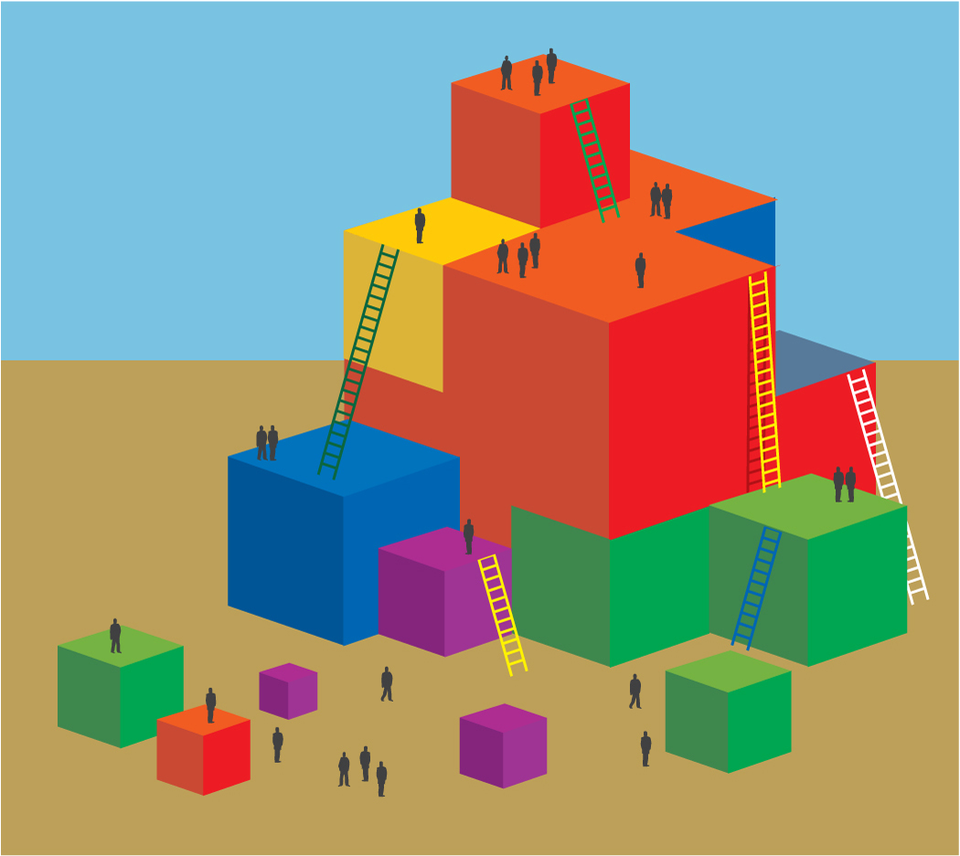
- Give each table a copy of a picture book that can be used for both visual and performing arts and another domain, such as mathematics, language and literacy, social-emotional development, or English-language development.
- Have one table member read the book aloud to the table group.
- Ask them to spend 15 minutes using the picture book as a starting point for one or more activities that combine the visual and performing arts with another domain.
- Participants can use Handout 9: Putting it All Together as a template for brain storming.
- After groups are finished documenting their ideas invite each group to present their ideas to all participants.
- Encourage table groups to demonstrate their best idea.

OPTIONS:
- Assign table groups specific VPA strands and domains rather than having each group to select their own.
- Give table groups boxes with materials and props to work with as they complete this task.

