
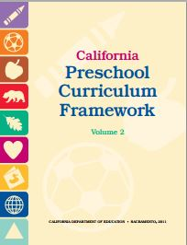
Visual and Performing Arts Domain
Guiding Principles

Guiding Principles | Page #  (PCF, Vol. 2) | Notes/Ideas
The arts are inclusive of all children. | p. 42
The arts are a language that is common to all. | p. 42 | l
The arts promote dispositions for learning. | p. 43
Children make their own meaning. | p. 43
Children are capable of creating original art in all its forms. | p. 43
Children learn about human connections, beauty, and appreciation of the arts. | p. 43
The child’s work is play. | p. 43
Children are active learners who thrive when challenged appropriately. | p. 44
Arts experiences for preschoolers are more about process than product. | p. 44
The arts reinforce the integrated nature of learning. | p. 44
Cultural competence is approached through art. | p. 44
The arts are motivating and engaging for learners. | p. 44
Arts can nurture the nurturer. | p. 45
The arts provide a unique means for families to interact. | p. 45
©2014 California Department of Education (CDE) with the WestEd Center for Child & Family Studies.

