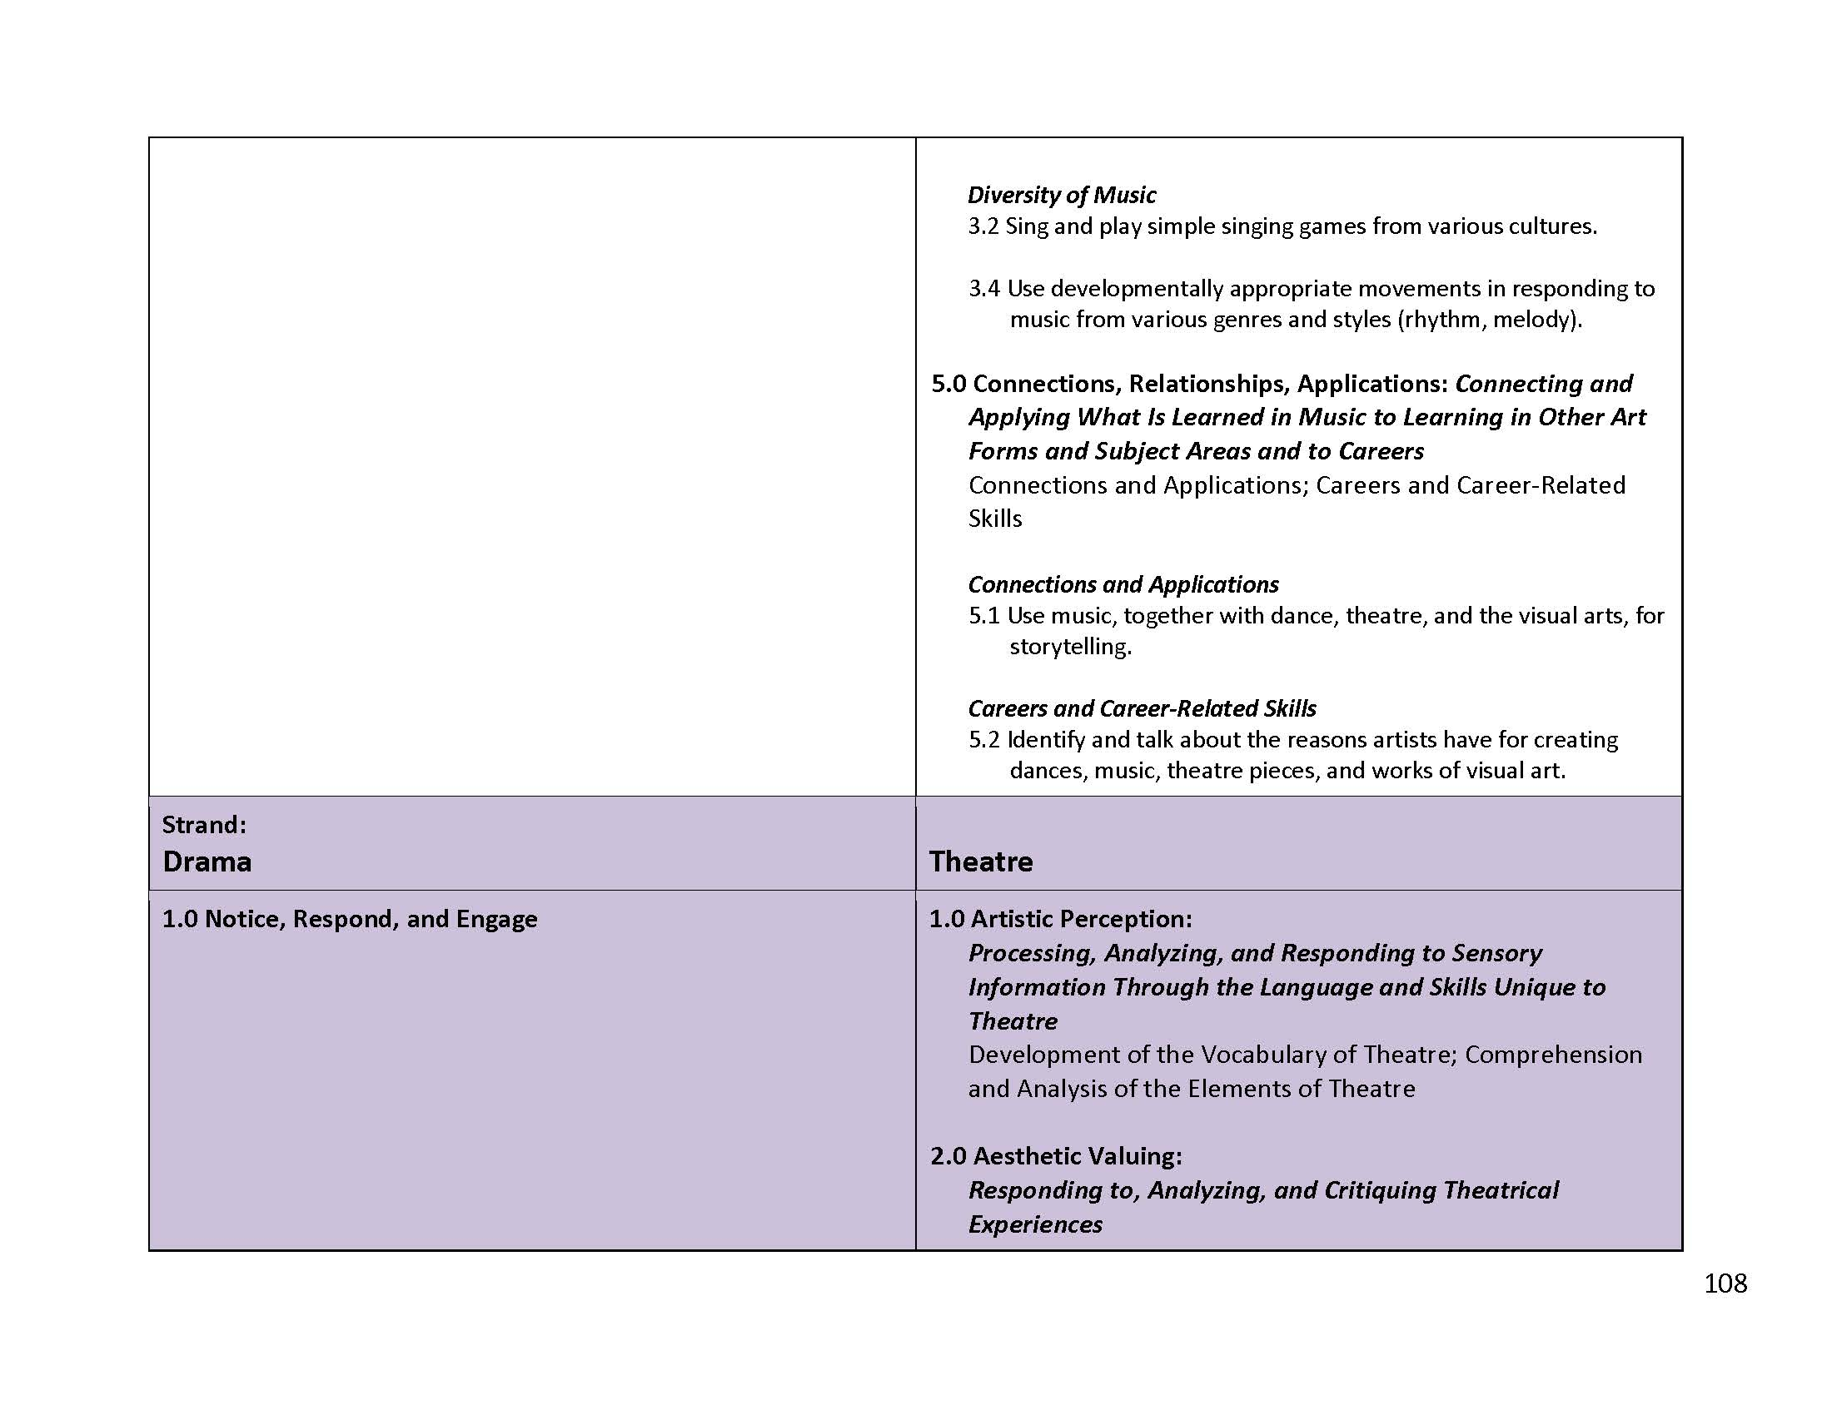

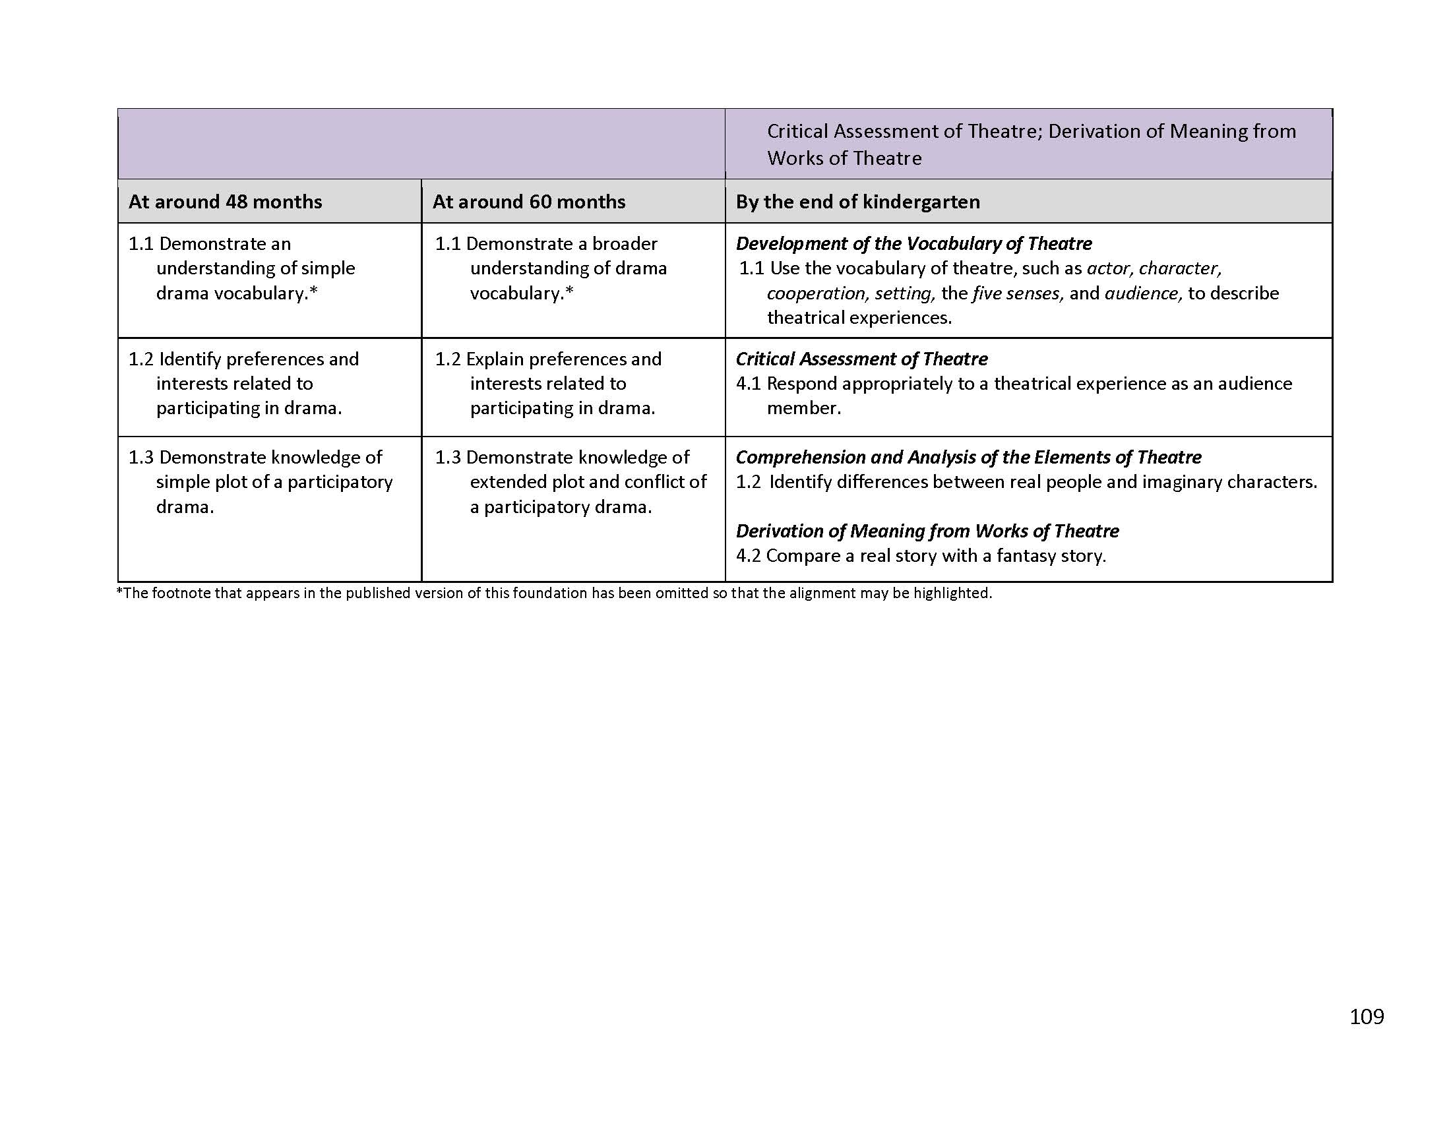

Excerpted from Table 1.13 Detailed View of the Alignment Between the Visual and Performing Arts Domain and the California Content Standards, *The Alignment of the California Preschool Learning Foundations with Key Early Education Resources: California Infant/Toddler Learning and Development Foundations, California Content Standards, the Common Core State Standards, and Head Start Child Development and Early Learning Framework* [CDE], pp.108-109.