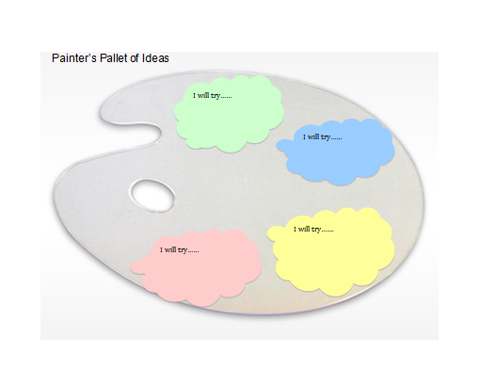

Social Emotional | - Self  - Social Interaction  - Relationships
Language and Literacy | - Listening and Speaking  - Reading  - Writing
English Language Development | - Listening  - Speaking  - Reading  - Writing
Mathematics | - Number Sense  - Geometry  - Algebra and Function  - Measurement  - Mathematical Reasoning
Visual and Performing Arts | - Visual Art  - Music  - Dance  - Drama
Physical Development | - Active Physical Play  - Fundamental Movement  - Perceptual Motor Movement
Health | - Health Habits  - Safety  - Nutrition
History Social Science | - Self and Society  - Becoming a Preschool Community Member  - Sense of Time  - Sense of Place  - Marketplace
Science | - Scientific Inquiry  - Physical Sciences  - Life Sciences  - Earth Sciences
Domain
Strands
Notes

