Visual Art Invitations through the Environment:
View, Build Skills, and Create Visual Art

Block Area


Science or Discovery Area

Sensory area
Outdoor Area

Dramatic
Play Area

Math Area
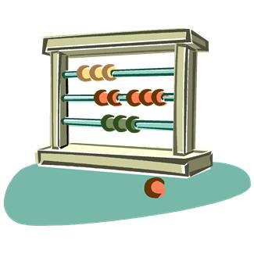
Literacy Area

Art Area


