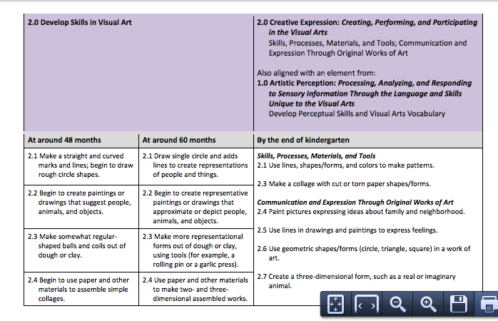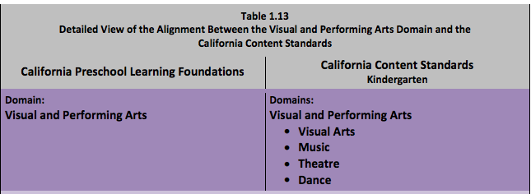

(*The Alignment of the California Preschool Learning Foundations with Key Early Education Resources* [CDE], pp.100-102)