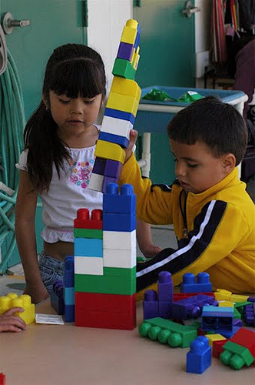



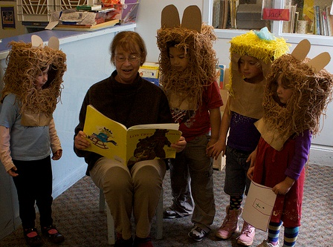

Questions to matching game:

1. My mom put one small carrot stick and three bigger ones in my lunch box. How many carrot sticks do I have?
2. How much larger do you think we can make this tower before it falls?
3. Goldilocks tasted two of the soups and then tried one more. How many soups did she try in total?