Rainbow of Self-Reflection



intent:
Participants consider their own interests and biases in providing learning opportunities for the science and
history-social science domains.

OUTCOMES:
Participants build a rapport with one another and begin thinking about the science and history-social science domains.


Materials Required:
- PPT slide
- Trainer notes
- Chart paper
- Costume materials

Time: 15 minutes
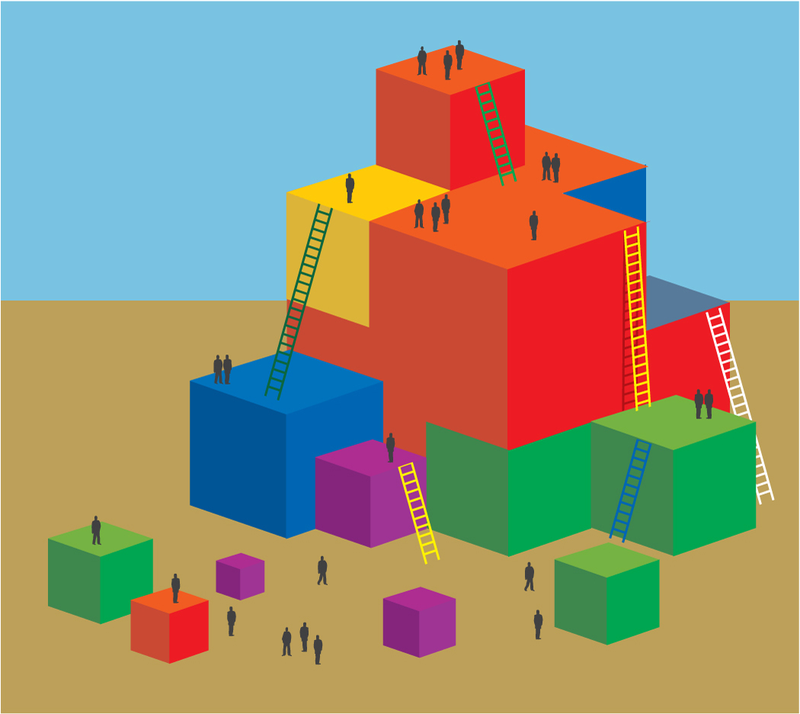
Process:
- Place “Which Scientist Are You?” charts in the four corners of the room.
- If acting out the four characters, prepare costumes and exaggerate the scripts. Have fun!
BEGIN:
- Distribute “Which Scientist Are You?” cards to the participants as they arrive or at the beginning of the workshop. Allow them a minute or two to read the four characters and decide which one best represents their style or approach to science. Of course we are all blends, just have them pick the one that most suits them.
- Direct participants to leave their seats and stand near the chart which names the scientist that best represents them. Allow four to five minutes to meet a few people (depending on total audience size) in each group, discuss with them why they chose that scientist, and have them share their thoughts about the science and history-social science domains.
- Optional: Have the four characters enter the room one at a time and stand next to the group they represent. Costumed characters take turns acting out the scripts, exaggerating with appropriate props.
NOTE: if you do not have four trainers you can play more than one character and do costume changes.
- Lead trainer waits for the audience to digest the skit and then begins summary:
  - This is just one way to look at individual variations in approaches to teaching science and social science. We all have different interests, biases, and strengths. Capitalize on your strengths while also considering that there are different, valid approaches that may benefit your children.
  - First, become aware of your strengths or interests and then intentionally balance them out to meet the needs of all the little scientists represented here who may be in your classroom.

