Vignette



intent:
Participants explore the concepts of self and practice applying a vignette and teachable moment in their daily routine.

OUTCOMES:
Participants deepen their knowledge of the social science domain, experience one way to apply a vignette, and share ideas of new ways to utilize interactions and strategies.


Materials Required:
- PPT slide
- PCF, Vol. 3 (Vignette)
- Cinderella or other diversity books
- Support materials:
  - Cinderella Stories
  - Analyze Books and Materials for Racism, Sexism, and Ableism
  - List of preschool age books about special needs

Time: 15 minutes
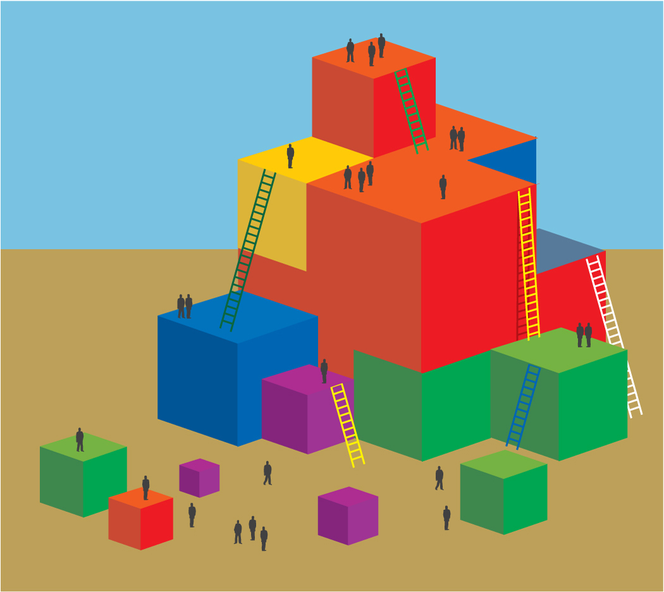
Process:
- Read through the vignette on page 54 of the PCF.
- Answer the questions on the PPT slide with your table group:
  - What is interesting about this vignette?
  - Have you encountered any messages about princesses similar to those Emma and Annie experienced?
  - The teachable moment shows one way to expand on this experience; what is another way?
- Invite participants to share out their ideas.
- Advance PPT to the Interactions and Strategy slide. Discuss that another way to approach this scenario might be through an intentional reading of a story.
- Bring attention to the books on the tables (Cinderella or Diversity).
  - If using Cinderella stories, share with participants that many cultures have a story similar to Cinderella. You can use these stories to expand preschool children’s thinking about what a “princess” might look like.
- Have participants take a moment to look through the book on their table.
- With their table group, participants discuss how this book, or another book, might be used intentionally for addressing a similar situation to that described in the vignette.
- Invite participants to share out ideas.

