Science: Imagine It



intent:
Participants visualize the multitude of experiences that children may encounter when they engage with the real
world through visualization.

OUTCOMES:
Participants participate in a visualization exercise and apply new ideas to planning for science and social science/history.

Materials Required:
- PPT slide
- Trainer notes
- Sorting template

Time: 15 minutes
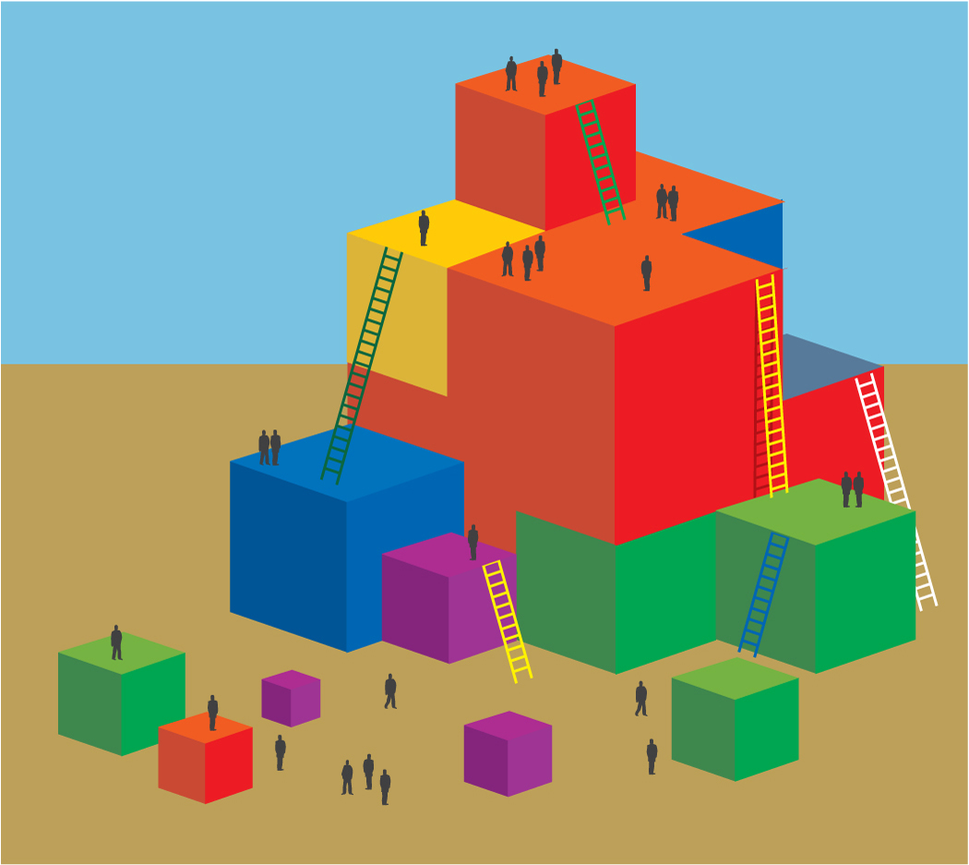
Process:
- Trainer begins by inviting participants to imagine with her/him:
  - “Together we are going to visualize that we are on a walk; and we will notice all the experiences we might have on this walk.”
- When trainer is ready, begin visualization exercise:
        - VISUALIZATION NARRATION: “Close your eyes and imagine taking a 10 minute walk that starts at your classroom door. Consider the weather, the smells, what is on the ground and in the air.”
        - After a few minutes, ask participants to open their eyes and write down all the things that children might encounter on the walk that they might be interested in or curious about.
        - On separate Post-it notes, have participants jot down at least four-five ideas or topics to investigate.
- When the visualization is complete, ask participants to discuss with their table groups all the experiences they visualized that might be relevant to science
- Ask groups to use the templates provided to sort their sticky notes into piles that fall under the different strands in the science foundations (physical science, life science, and earth science).
- Ask groups to consider which strands have the most ideas and why that might be the case (We tend to teach to our interests.). Emphasize that it is important to get a solid foundation in all three areas.

