What does it look like?


intent: Participants will connect with other participants as they reflect on what the overarching principles look like in action in a typical early childhood day.
.

OUTCOMES: Participants will be able to visually connect overarching principles to practices during a typical program day.

Materials Required:

- Boxes of photographs, at least one for each strand/1 box for each table
- Laminated 3 x 5 cards (each with one overarching principle)
- Eye-level posters hung throughout the room. Title each with one overarching principle.

Time: 20 minutes

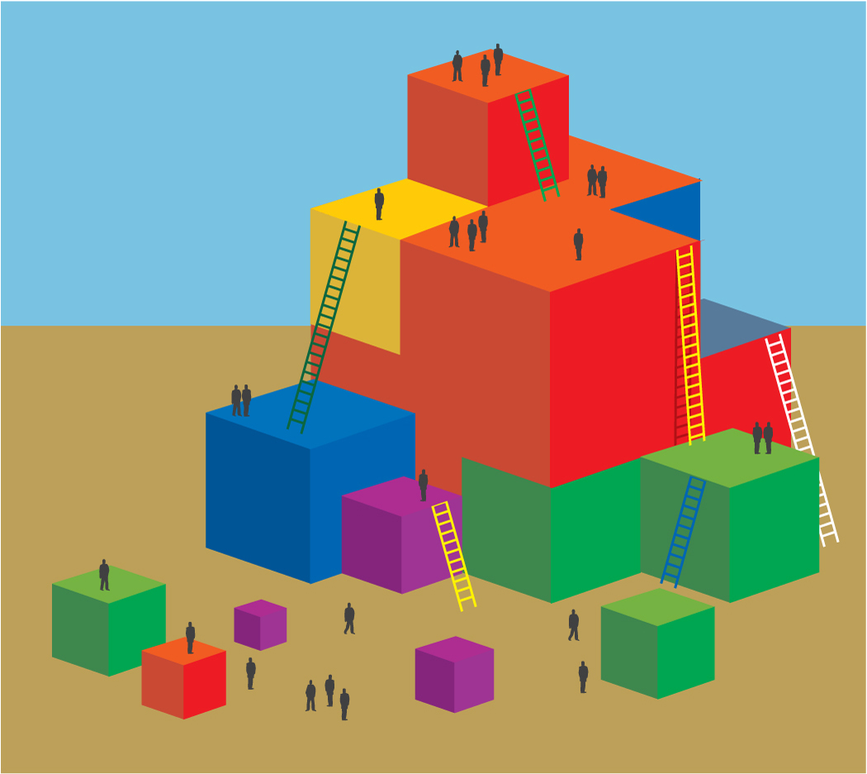
Process:
- Prior to participants arriving, place box on or next to each table.
- Invite participants to look at the box of photos at their table. Explain that the photos in their box represent one of the domains in Volume 2.
- Have one participant from each table select one or more 3x5 cards to determine the table’s overarching principle(s). (One or two per table depending on size and participants).
- Invite participants to work together to identify at least three photographs from their box that exemplify or relate to the assigned principle(s).
- Ask participants to attach a post-it to each picture with a description of how it relates to the principle(s) and to hang their photos and descriptions on the matching poster in the room.
- During break or other activities, participants can wonder around the room to processes what others have chosen and written.

OPTIONS:
SUMMARY:
- Implementation of overarching principles should be evident throughout the program day.

