Presentation Skills for CPIN
Part 2 of 4

building rapport

Being in rapport is the ability to enter someone else’s model of the world and let them know that we truly understand their model. – Brooks (1989)

What is building rapport? Rapport is a mutual understanding between individuals that they share each other’s concerns.

Why is building rapport important in training? For participants to respect the trainer and participate fully in the content, the trainer must establish at least a minimum of rapport with the people. Sharing a few common professional concerns helps communicate to the educators that you understand their work environment – the context in which you are asking them to change practice.

how to build rapport | how to build rapport training
share personal and professional connections
be fully present in the training
be aware of your body language
listen impeccably
communicate acceptance

listening

What is listening? Listening is an active activity that involves receiving, deciphering, and perceiving a message with the intent to respond. Planning well ahead for training improves a trainer's ability to listen.

Why is listening important as a trainer? Listening helps the trainer determine where the participants are terms of the change process, the implementation of a new practice, and/or the attitude hindering implementation.

3 questions to ask yourself as you listen

- What are the facts and details embedded in the speaker’s words?

- Are the spoken messages free of generalizations, bias, of blame and finger pointing?

You hear… | You might respond…
Universal Quantifiers  all, everyone, never, forever, always | Was there a time when that wasn’t true? Not a single person? Every time?
Modal Operators  should, must, necessary, can’t, have to, ought | What is the barrier? Whom do we talk to about that? What do you think might happen if you did that?
Unspecified Verbs  prepare, make, think, do, feel, know, learn | What does that look like to you? How will you do that? Tell me what ‘know’ looks like in your classroom?
Unspecified Nouns  children, clients, women, they, parents | Which parents? Which manager or director? How many children is that?
Comparators  better, larger, more effective, less useful | More effective than what? How is that less powerful?
Adapted from Laborde (2012)

- Are there patterns of language or comments that tell us about the speaker’s way of thinking? (Garmston, 2009)

  - Power and Efficacy. I have the power to make a change. I can produce results and make a difference. I can reach goals by aligning internal and external resources. Alternatively, I have little or no control. Forces, outside of me, entirely constrain. My results do not matter.

  - Flexibility and Openness to Feedback. I welcome criticism and am determined to grow from it. I like new ideas and different ways of thinking. I can deal with uncertainty and ambiguity. Alternatively, I know what I’m doing and do need not external ideas or assistance. My way is tried and true. Collaboration and stretch goals are of little or no value.

  - Craftsmanship and Skilfulness. I have the skills and experiences necessary to complete the work. I’m quick to admit my weakness and seek ways to improve. Alternatively, I don't know what to do. I don’t have the technical ability to accomplish this work.
comments of a new teacher

I think things are going well so far. I do have a bunch of kids who don't pay attention and are behavior problems, they're just bad kids and don’t want to behave. The other teachers at my level agree with me, and they feel sorry that I have to deal with all of them in one room. I’ve tried calling the parents, but they are no help at all. I do need to know more about this Creative Curriculum. I’m not sure how I’m supposed to implement this program with this group of needy children.

- What are the facts and details embedded in the speaker’s words?

- Are the spoken messages free of generalizations, bias, of blame and finger pointing?

- Are there patterns of language or comments that tell us about the speaker’s way of thinking?

nonverbal communication

Only 7% of the emotional meaning of a message is communicated through the exchange of words. Some 38% is communicated by vocal intonation, and the remaining 55% is expressed through gestures, posture, facial expressions, and other physical cues. -- Bloom (2005)

I can never bring you to realize the importance of sleeves, the suggestiveness of thumbnails, or the great issues that may hang from a bootlace. -- Sherlock Holmes to Watson in "A Case of Identity"

What is nonverbal communication? Nonverbal communication is a broad term used to describe any method of transferring information without words and may include body language and facial cues, fashion and personal grooming, hand gestures, and graphical signs and design.

How is nonverbal communication important to training? Nonverbal cues may provide the trainer with hints that a teacher is resistant or does not understand. Knowing a few clues about body language may cue the trainer to check for understanding or probe for specificity. The trainer should also be aware of his/her body language to send physical messages that support the verbal messages and the precepts of trust and rapport.

Tips: Information about reading body language can be greatly over-generalized. The point of studying body language in the context of training is to provide the trainer with one of many interpersonal communication tools. The best use of reading body language is for the trainer to check for understanding. For example, if a person leans back and folds his arms it may signal the person is resistant to the message. The trainer might say in response, "How might I further clarify what we're talking about?" Alternatively, the reclining and folding of arms may mean the teacher’s back aches. Either way, the trainer might probe the nonverbal clue by checking for clarity ("How might I further clarify what we're talking about?") and then move on with the conversation. In general, the trainers' body language should be open and forward.

open closed -- forward back

OPEN and CLOSED gestures are the most obvious. People with arms folded and legs crossed, and bodies turned away are often signaling they are rejecting messages. People showing open hands, fully facing you and both feet planted on the ground are most likely accepting them.

Acceptance -- open body language -- might be indicated by: standing erect, sitting with legs apart, open palm, raised eyebrows, smiling, arms uncrossed, nodding, and eye contact.

Rejection -- closed body language -- might be indicated by: hands clenched, frown, head down, legs crossed, sitting/moving back, slumped posture, doodling, finger/foot tapping, arms crossed.

FORWARD and BACK gestures indicate whether people are actively or passively reacting to communication. When a person is leaning forward and pointing towards you, it is a strong indication s/he is actively accepting or rejecting the message. When a person is leaning back, looking up at the ceiling, doodling on a pad, cleaning her glasses, she may be either passively absorbing or ignoring it.

Acceptance -- forward body language -- might be indicated by leaning forward, head tilted, sitting up, extended arm or hand.

Rejection -- back body language -- might be indicated by slumped posture, hands on hips, leaning or moving away.

Examples
 |  Open   Closed   Forward   Back | 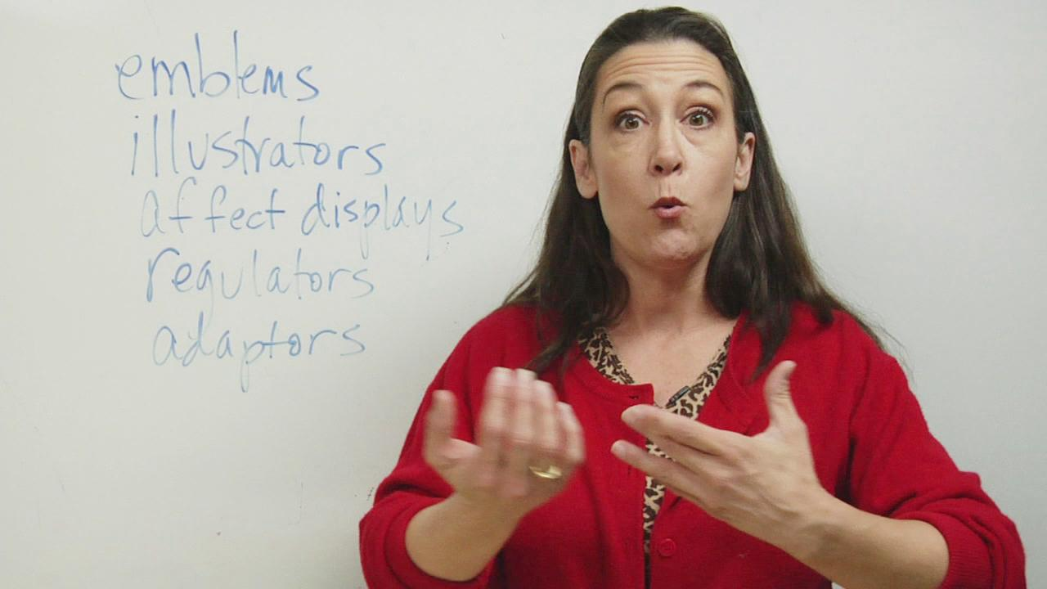 |  Open   Closed   Forward   Back

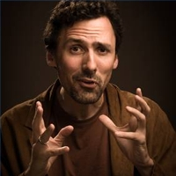 |  Open   Closed   Forward   Back |  |  Open   Closed   Forward   Back
 |  Open   Closed   Forward   Back |  |  Open   Closed   Forward   Back
 |  Open   Closed   Forward   Back |  |  Open   Closed   Forward   Back
 |  Open   Closed   Forward   Back |  |  Open   Closed   Forward   Back

giving directions

How many times have you attempted to type in a password before carefully reading the directions? Oh, the password needs a capital letter and a special character and a number and more than eight total characters and less than 10 characters! Attention to instructions is essential. Directions in a workshop provide an excellent opportunity to keep the pace or momentum of training moving smoothly and quickly. Skilled trainers know the value of explicit, brief directions for workshop activities. If not careful, there is the off chance of losing participants’ focus on the work by crowding in too many steps or providing only a vague outline of steps. When in doubt, write them out. Reviewing, expanding, or collapsing steps is a worthy endeavor with the payoff of increased participant attention in-between activities. Loose and long transitions are the most frequent points where participants lose focus during a workshop. Keep your transitions tight with focused steps that let people know what to do.

1. get the attention
It is imperative to gain 100% or almost 100% of the eyes and ears of participants when providing directions. This strategy helps to reduce having to repeat directions or respond to questions about the directions too frequently. Additionally, this practice is respectful of other participants trying to listen to directions without the distraction of side conversations. If the group is small, say only a handful of people, then a flashy attention signal is not necessary. Conversely, huge groups need an obtrusive signal to help keep the crowd with you. There are many ways to get the group's attention. Here are several ideas that may be tweaked to fit your training style:

- Lights. Turn lights on and off.
- Music. Start or stop background music. Play a unique ringtone like a duck, rock music, or horn on your phone.
- Gesture. Teach that when you hold up a specific object, like a toy or stick or your arm, that means everyone is to stop and listen. Alternatively, start a simple movement, like silent marching or pumping your fist, that everyone repeats until the entire room is silent and mimicking your gesture.
- Noisemakers. Loud items such as chimes, drums, rain sticks, bells, tambourines, maracas, finger cymbals, baby rattles, etc. are common. Use the noisemaker at the microphone if necessary, doesn't pierce eardrums.
- Teach a chant participants complete. Trainer: "Ready to rock?" Participants: “Ready to roll!” Trainer: “Carmel!” Participants: “Macchiato!”
- Rhythm. Start a simple clapping rhythm and repeat it a few times until everyone joins in the rhythm with you.
- Stand. Ask participants to stand when they finish a task at hand. Just as the last person starts to stand, deliver the next steps.
- Tell. Say, "This is my signal to listen. I'll say, ‘Finish up your conversation.' I'll wait for about 30 seconds. Then, I'll ask you, ‘Give me your attention please.'"

2. be explicit
For more detail on delivering directions than you could ever hope for, see Teach Like A Champion 2.0 (2014) and The Skillful Teacher (2008). In the meantime, keep in mind these three simple attributes and deliver directions at every opportunity with the following criteria:

specific. The directions tell participants what to do, not what not to do. For example, say, “Open the folder and take out the purple handout. Hold up that handout.” Do not say, “Don’t go into your binder; go the folder instead. Ignore the red and yellow handouts and don’t worry about the pictures right now. Find that purple handout.” The later example focuses on what participants should not do and is more confusing than helpful.

observable. Tell participants to do something that can be easily seen and is an action. Instead of saying something vague like, “Find the photograph,” say, “Get the photograph and hold it up so I can see it.” Instead of saying, “Fill in the hand-out,” say, “Once you finished writing answers in the hand-out, stand up so I can see you finished.”

sequential. Give no more than three steps at a time and stop and check. Check that everyone has followed the steps. Check by saying, "Point to that page number…check to see if your partner has the purple handout…" Then give more steps (no more than three) as needed. Did you forget a step? Just correct it in the next set of steps. Do not talk over participants when they are following your directions. People do not hear, you are teaching participants it is okay to only half-listen to you, and it's the sign of novice trainer. If you forgot or incorrectly stated a step, wait until the group completed the action you requested, get everyone's attention again, and provide more or corrected steps. If a genuinely colossal mess occurs and everyone is in the wrong place, use a signal, gain all eyes, and start over with directions. Alternatively, navigate the room and make corrections with individuals or small groups without shouting out across the room.

in-cue. Teach Like A Champion 2.0 (2014) recommends an in-cue as the last sequence in your set of sequential directions. An in-cue is a consistent word or phrase that says to participants, “It is time to stop listening to me and start the action.” It is delivered quickly, consistently, concisely, and with a bit of energy. Make up your own or try any of the following in-cues at the end of your directions: “Ready, begin!...Go!...On your mark, (dramatic pause) start!...You may begin…Please do that now." Keep your in-cue consistent throughout the training for the highest impact.

3. stand still for directions (move around at other times!)
Roam the room during presentations while delivering information, telling a story, or engaging with participants during small group work. However, stand still when you deliver directions. Try to select one general spot in the room from which to provide directions to activities. Both Garmston (2005) and Lemov (2014) advocate this strategy. The technique provides a subtle cue to the group to pay attention when you are in this spot. This aids in the pacing of the workshop as it takes less time to gain everyone’s attention. Additionally, it serves as a reminder to try and get all eyes and ears before plowing into important or complicated procedures.

4. give a warning or notice the end is coming
Just like a pilot reminds passengers the trip is ending soon or the waiter tells you he will be back in a few minutes with the dinner check, you provide a gap of readiness for what is next when reminding learners the activity will close soon. When the close of an activity is imminent, remind groups of the enduring time, so they are likely to complete the activity as scheduled. This tactic allows participants to disengage physically and affectively from activities. It also increases the likelihood they will attend to the next set of directions. This strategy is different from Avoid T Word in that it keeps the group focused on completing the learning activity rather than worrying about the clock. Select a formula from the list below or create a unique way to alert participants to the remaining time.

- Tell the whole group, “You have two more minutes to finish this activity.”
- Circulate to each group, get the attention of the leader and indicate the remaining time with your fingers.
- Write the remaining time for a break or activity on a flip chart, whiteboard, etc. Cross out the time periodically and replace it with the countdown minutes.
- Use one of the many slide presentation time applications available electronically.

Directions #1

Now, we will swap ideas. You will look for specific answers or ideas from this handout to share

with other participants. Find the blue handout. You might want something to write with. (waits)

Find a sticky too. Start reading the handout for ideas to share with your group. Count off 1

through 5 at your table. 1s read the top section of the handout, 2s the second section, etc. Start

reading and finding ideas to share. We will discuss more about the ELD measures later, but now

just focus on this handout. You have 5 minutes. (All stated from one spot in the room.)

Attributes of Effective Directions

Gain 100% Attention

Explicit

Specific “Focus on What to Do”

Observable “Show it”

Sequential “First, second, third…”

In-cue “Verbally Cue When to START directions”

Stand Still

Give Notice “Warn before ending”

Fix up the directions if there were errors. How would you state similar directions and include all the attributes of Effective Directions?

Directions #2

(Presenter stands in one spots and holds up an example of a photo.) You will look at a photo

and make observations of it. I will be walking around and talking with each table while you do

this. You will have about three minutes. Before you begin, don’t be distracted by cute kids and

the learning activities you see in the pictures. Look for some examples of evidence that could be

included as a descriptive or interpretive data. After you’ve made the observations, we’ll sort

them into categories. Begin. (30 seconds; starts moving among tables and shout out over the

group work). “Make sure you are not just saying the child is cute. Oh, and write down your

notes about what you are describing or interpreting.”

Attributes of Effective Directions

Gain 100% Attention

Explicit

Specific “Focus on What to Do”

Observable “Show it”

Sequential “First, second, third…”

In-cue “Verbally Cue When to START directions”

Stand Still

Give Notice “Warn before ending”

Fix up the directions if there were errors. How would you state similar directions and include all the attributes of Effective Directions?

fielding questions

strategies for fielding questions

When a participant is incorrect…

It is essential when adults are learning new information to make sure, to the extent possible, the information floating in the room is correct. Be sure to correct incorrect information. Responses, when participants answer incorrectly, are at best brief and unemotional:

- No, (with a warm and sincere smile) the correct answer is ______.
- That’s not quite it; try again.
- No, that is not what I wanted. Please tell me why that’s not an example of _____.
- You had the first part right. The correct answer is interpretive.
- That is an example of Integrating. Building is the level for this scenario.
- No, (with sincerity) but it's good you brought that up because others probably thought that, too.
- The correct answer is domain, not measure.

There is no hint in this kind of response that adults are so fragile they cannot make a mistake without being devastated. Be excited when participants or you make mistakes. Celebrate participants who provide wrong answers (give a quick prize or group cheer) for being brave and allowing the group to learn what you, as a presenter, would not know if they had not revealed the misinformation. Adapted from Harmin & Toth (2006); Saphier, Haley-Speca, & Gower (2008).

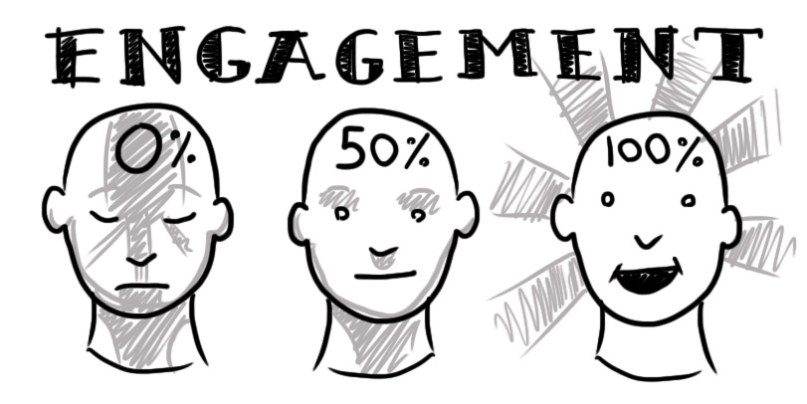
keeping participants engaged or active during training

Engagement is about what the participants are doing with you, with each other, and with the topic. Comprehension of a topic is directly proportionate to the visible or verbal interaction participants have with the subject. Basically, the more the group talks, writes and performs regarding the training topic, the more they absorb and retain. Conversely, the more they sit and listen without interaction, the less likely they are to seize the subject. Call it what you will – interaction, engagement, active participation, or involvement. Sitting and listening to a talk, speech, or lecture can be informative; however, when we examine that structure through the lens of participant learning, there is not much bang for the buck with “sit and get” training. Research supporting this idea is systematically examined by academics Biggs and Tang (2011). The idea that adults require active engagement for effective learning is echoed by several authors: Auerbach, Knowles, Thiagi, and Silberman. Increasing participants' active participation in the learning process not only improves their understanding of the new information, but it also increases their perception of time passing. When we're engaged, especially in something of substance, minutes turn into moments. Well-built engagement adds energy, comprehension, and velocity – there are just so many paybacks to escalating active participation. Most adults are internally motivated and will find a way to be engaged if you don’t engage them. Knitters will knit. Jokesters will interject. Naysayers will blurt out. The job of highly effective trainers is to design productive ways to maintain everyone’s interest in the topic at hand – constructively.

Ideally, how frequently should participants be interacting? Lots of people provide advice about how long to go before engaging learners. Silberman advises active training about every 8 minutes. Science education researcher Mary Budd Rowe found that about 2 minutes of interaction for every 10 minutes of content resulted in numerous benefits for learners. Master trainers keep participants engaged almost every minute of the lesson. (It’s not as daunting a task as it first sounds.) At a minimum, try not to move beyond 3-5 minutes before engaging attendees in some observable fashion. Before deciding that active engagement for the majority of training time is not for you, check out the following structures and see how they might fit into an upcoming training. Study long enough, and you'll start to find ways to design training to hit full participant engagement 80, 99, and even 100% of the time.

interactive reading strategies
Adapted from Opitz and Rasinski (2008) and Fogerty (2009)

- echo read. The presenter reads first, then participants echo read. Usually, one sentence is read at a time.

- choral read. The whole group reads a portion of the text together.

- whisper read. Participants read aloud but in a whisper. The presenter monitors the group or class to see and hear who is reading for themselves. This is an effective strategy for a small group.

- paired or triad read. One partner reads and the other partner listens. Usually, each reads a sentence or paragraph at a time. The listener has a job to highlight, underline, or point to the passage being read. Partners read and then ask questions of each other or share highlighted information at the end of the reading. This can be done with triads – one reads, one highlights, and one summarizes what was read.

- sticky note. Use sticky notes to make notes while reading. There are a specified number of sticky notes to complete.

- text code. Participants are asked to mark the text very specifically: underline main points, highlight new information, draw a box around unknown words, mark a ? beside confusing info, mark an ! beside new info, etc. You can make up your own coding system.

- read and highlight. Partners are given highlighters or colored pencils to mark information that is requested.

- stop-n-jot. Participants are given a passage to read. At the designated places or end of the passage, participants stop and jot down a question, comment, summary, key phrase, or other information.

- inquiry read -- Video Viewing or CD Listening. Participants read silently for a purpose. The presenter gives participants a question to answer from the text or an answer they have to find support for from the text.

- break-in read. One group of participants or the presenter starts reading orally. All other participants follow along with a job: writing notes or words, tracking text, or other. The presenter stops mid-sentence or mid–passage to switch who reads next.

- you decide. Partners can read a passage together in any way they decide as long as the reading is observable.

alternatives to calling on one participant

- Roam and tell correct participant responses. Jot down responses if you need and state them to the entire group orally.

- Roam and write down correct participant responses and post on a chart, overhead, or document camera and show them to the entire group. You might include the participants’ names along with the examples.

- Roam and collect an accurate model from a participant – from their paper or whiteboard -- and show it on the document cam to the whole group. Alternatively, have a participant with the accurate model write it on the board while other participants finish up their work. Then, highlight the model to the whole group.

- Roam and check responses and do not share them. Just say (if responses are correct), "I saw everyone is on the right track.” Then continue with the lesson.

- Roam and say the correct response to the group. This is particularly useful when you found no one writing or saying the correct response.

- Collect quick writes and read responses later or as participants work on seatwork.

If you must call on one participant to respond, always use a group alert (Kounin, 1979). Give all the other participants a task to complete as they listen. At a minimum, give participants a covert engagement strategy; at best, give them an overt engagement strategy to complete while listening. For covert engagement, say, “Everyone turn and look at Maureen. Maureen, go ahead.” Or, “Everyone say, ‘Good morning Maureen!’” (Wait of audience response.) “Maureen, share your answer.” For overt engagement, try one of these two prompts:
- “Listen to Maureen’s answer. As she talks, jot down what she ways…write down any key terms you hear her use…compare your answer to hers.”
- “Listen to Maureen’s answer. If you have the same answer -- underline, highlight, or put a star beside it. If you have a different answer, write down what she says.”

If you forget the Group Alert as soon as the participant gives a correct, oral response, say, “Now, write down that answer in your notes. If you already had it, underline or highlight it." Alternatively, “Two participants just gave their responses, turn and tell your neighbor what they said in your own words.”

respectful ways to gain and maintain adult engagement
~ ask for it, expect it, require it

Talk About…

- Tell direct and clear expectations. “Do _____, now.”
- Reinforce participants for the desired behavior. “Thank you for that beautiful choral reading!”
- Repeat the request twice when you see not everyone is responding before moving on. “Oh, I don’t think I heard everyone! Let's reread that line from the slide…"
- Speak privately to a participant not responding. "I just wanted to check in and see how the training is working for you." If one person decides not to participate in a given activity, don't make a big deal about it.

Walk About…

- Walk around the room after giving directions.
- Stand next to or near a participant or table not participating in the activity. Many times your mere physical proximity increases participation.

Look About…

- Scan faces of the participants to who is speaking, writing or responding.
- Make direct eye contact with a participant not responding. Smile.

Connections and Application

Review the language and literacy training model.

Highlight places where you’ll be using interactive reading strategies.

Jot down notes where you need to pay attention to your body language, listening skills, explicit directions, and the change process. Given today’s training, how will you be prepared to respond and interact with participants? What will you say or do?

Selected Sources
Bailey, B. (2011). Managing emotional mayhem. Orlando, FL: Conscious Discipline.
Bailey, S. & Bailey Darrell. (1992). Changing the agent: accelerated strategies to change whole systems. Vacaville, CA: Bailey & Associates.
Biggs, J., & Tang, C. (2011). Teaching for quality learning at university. New York, NY: McGraw-Hill International.
Bloom, P. (2000). Workshop essentials. Lake Bluff, IL: New Horizons.
Fullan, M. (2011). Change leader: Learning to do what matters most. Hoboken, NJ: Wiley.
Garmston, R. and Wellman, B. (2009). The adaptive school: Developing and facilitating collaborative groups. Norwood, MA: Christopher-Gordon Publishers.
Garmston, R. J. (2005). (2nd ed.) The presenter's fieldbook: A practical guide. Norwood, MA: Christopher-Gordon Publishers.
Hall, G. E., Gollnick, D. M., & Quinn, L. F. (2013). Introduction to teaching: Making a difference in student learning. Thousand Oaks, CA: SAGE.
Harmin, M., & Toth, M. (2006). Inspiring active learning: A complete handbook for today's teachers. Arlington, VA: ASCD.
Hord, S., Rutherford, W., Huling-Austin, L., and Hall, G. (1987). Taking charge of change. Alexandria, VA: ASCD.
Knowles, M. (2004). The adult learner: The definitive classic in adult education and human resource development (6th ed.). Burlington, MA: Elsevier Inc.
Lemov, D. (2014). Teach like a champion 2.0. San Francisco, CA: Jossey-Bass.
Lemov, D., Woolway, E., & Yezzi, K. (2012). Practice perfect: 42 rules for getting better at getting better. San Francisco, CA: Jossey-Bass.
Noddings, N. (2013). www.greatergood.berkeley.edu. University of California, Berkeley: The Greater Good Science Center.
Reeves, D. (2009) Leading change in your school: How to conquer myths, build commitment, and get results. Alexandria, VA: ASCD.
Rush, D., & Shelden, M., (2011). The early childhood coaching handbook. Baltimore, MD: Paul H. Brookes.
Saphier, J., Haley-Speca, M. A., & Gower, R. (2008). The skillful teacher: Building your teaching skills (6th ed.). Acton, MA: Research for Better Teaching.
Silberman, M., & Auerbach, C. (2011). Active training: A handbook of techniques, designs, case examples, and tips (Vol. 13). San Francisco, CA: John Wiley & Sons.
Trainers Warehouse. Located at www.trainerswarehouse.com, Trainers Warehouse offers hundreds of innovative and fun products for trainers and educators. Popular products that improve retention and make training more engaging include game show templates and buzzers, icebreaker and team-building games, table toys, and presentation software. Trainers Warehouse, a woman-owned business, is based in Natick, MA.

Several of these strategies came from workshops of the educational researcher and curriculum writer Anita Archer, Ph.D., professor emeritus from the University of Oregon and UCLA.
Many of these strategies come from Anita Archer as well.

