Directions: Place your sticky notes under the strand that best
represents the idea.

Physical Sciences
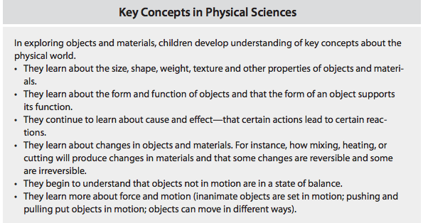

Life Sciences
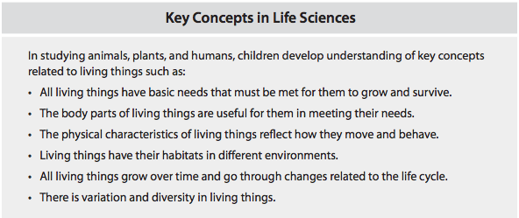

Earth Sciences
