Experiencing Universal Design for Learning

intent:
Introduce the concepts of universal design in teaching and learning

OUTCOMES:
Participants will experience how to engage, express and represent information in multiple means through a simple teaching/learning activity. They will explore how UDL principles support unique learning needs through the design of environments, materials, and teaching strategies.


Materials Required:
- PPT slide
- Pencil
- Handout of planning map slide
- Display of common materials that could be used to teach about circles and roundness (hoops, rings, string, jump ropes, bubble soap, balls, paper/markers, sand trays, etc.) with a multisensory approach (optional)

Time: 15 minutes

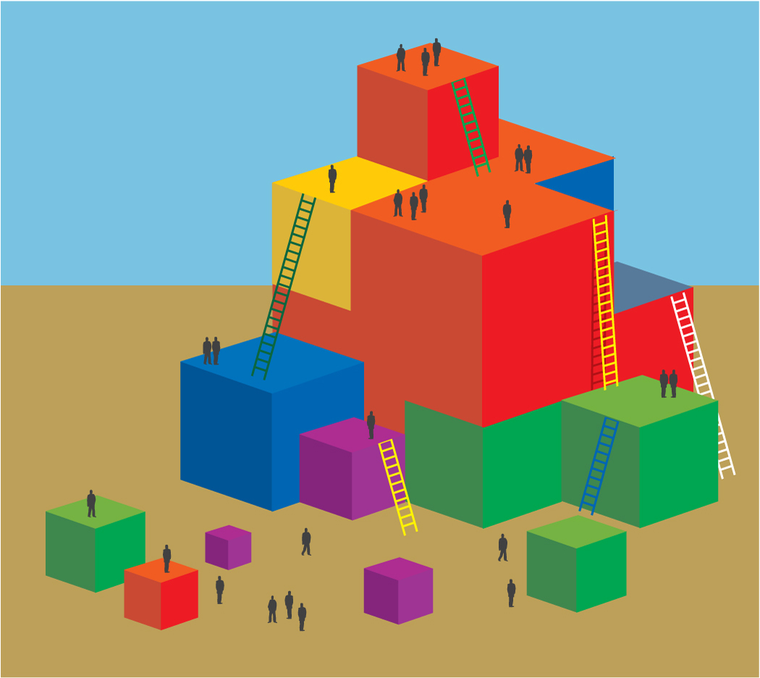
Process:
- Trainer sets the stage “Let’s pretend that I am teacher and I have decided to teach you all to identify a circle. (The circle appears on the second click.) In a comical manner, as the circle appears, say, “Children, this is a circle!” Ask a few audience members, “What is this?” and elicit the response, “A circle.” “So now everyone knows circle, right?”
- Now we are going to think about a circle through the lens of Universal Design for Learning.
- Ask participants to find examples of circles around the room. Invite them to demonstrate “circle” with the four prompts on the slide (draw one, find one, make one, show us).
- Pass out a copy of this slide as a worksheet to teams of participants and give them time to brainstorm with the materials displayed, to see how many ways they can think of to draw one, find one, make one, show us.
- Invite each table group to take notes for a share out.
- Invite groups to share out and praise creativity.
- Lead a brief discussion to collectively brainstorm various ways kids can engage in “circle” using the four prompts on the slide.
8. With the entire group now think of a specific child. How might a teacher gather information about circles from a child with...?
- A hearing impairment
- Vision impairment
- Physical challenges

OPTIONS:
- Instead of inviting all participants, have trainers act out the activity in front of the group.
- Instead of using a circle, use domain related content. For example if doing this activity in physical development, use the idea of throwing a ball; for writing, use a letter, etc.
- After the circle lesson, connect back to foundations by ask participants to identify domains that could be addressed through the activities (ex. math, literacy, social-emotional, physical development, etc.).
- Post the completed handouts around the room.

