Time Machine



intent:

The intent of this activity is to have participants gain experience using the Preschool Curriculum Framework (PCF)
to enhance their environment.

OUTCOMES:

Participants will read and reflect upon the environmental suggestions listed in the PCF. This activity will help participants understand the potential ways they can utilize the PCF to guide them in the improvement of their environment.


Materials Required:

- Environment section of the PCF
- Time machine handout
- (Optional) Back to the Future music

Time: 10 minutes

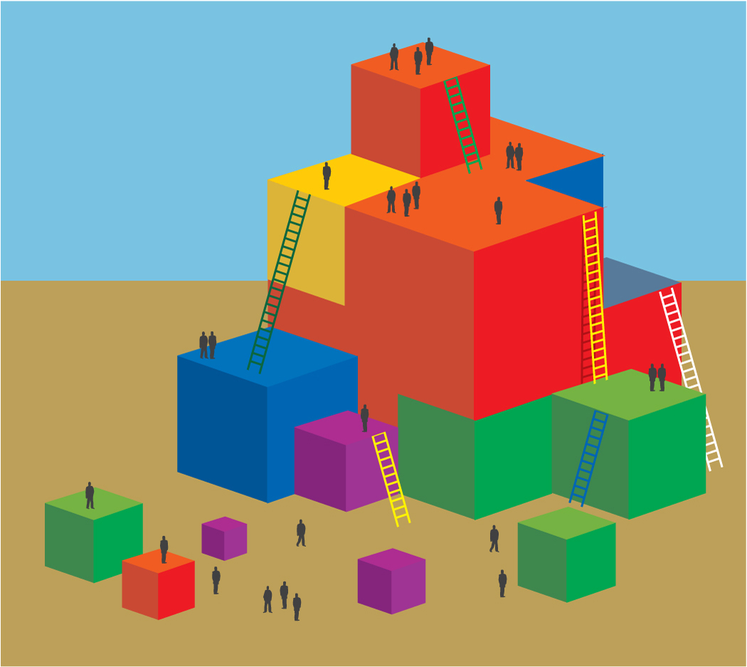
Process:

- Invite groups to turn to the PCF section that addresses the health environment (pp. 229-231), and read together.
- Allow five minutes for participants to discuss all the potential ways they might enhance their environment using the health ideas from
the PCF pages they just read.
- Give participants the following directions:
  - Step into your time machine.
  - Travel forward six months.
  - Look at your amazing successful program!
  - What do you see, hear, and feel that is making the health environment a success?
- Using the Time Machine Handout, invite participants to represent what they saw in the time machine. They can write, draw, etc.

SUMMARY:

- Once participants begin to talk with others in the group, they will uncover new ideas for the potential improvement of their environment.
- Participants will relate ideas from the PCF to their hopes and dreams for their environment.

