Health Habit: Integrating Habits



intent:

The intent of this activity is to have participants brainstorm for activities that can be used in the classroom to facilitate children’s development of the health foundations, and to use the Preschool Curriculum Framework (PCF) to enhance these ideas.

OUTCOMES:

Participants will reflect on their personal knowledge of health habits and utilize the PCF, real life objects, and the daily routine worksheet to integrate health activities into the classroom.


Materials Required:
- Integrating Health worksheet
- Bag containing a variety of health items
      - Examples: Toothbrush, sunscreen, apples, carrots, hand sanitizer, tissue, washcloth, hair brush, and band aid.

Time: 20 minutes

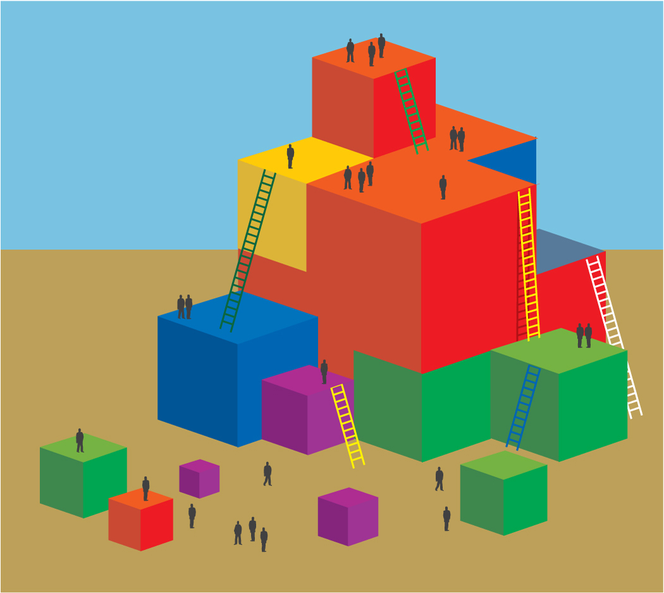
Process:

- Direct participants to the Health Habits section of the PCF.
- Allow time for participants to find it independently, then reference the footer to check for understanding of the PCF organization.
- Highlight and read one Interaction and Strategy sentence aloud.
- Invite participants to read more interactions and strategies with their tablemates before completing this activity. Allow about 5 minutes for reading.
- Direct participants to the Health Box on their table.
- Have participants explore each item in the box and discuss its connection to health.
- Invite participants to take out the Integrating Health worksheet.
- Ask each participant to select one item from the box and think about how they would use that item in the classroom to support children’s development of health knowledge and practice.

- Invite participants to write down their ideas on their worksheet and share with their tablemates.
- Debrief Options:
  - Allow time for each table group to share their favorite ideas.
  - As a table group write down the health habit foundations being addressed by each idea.
  - Have participants think about a specific child in their program that would benefit from targeted support of health foundations.
    - How might the ideas they wrote down specifically support this child?
  - Have participants think of a specific staff member that would benefit from focused discussion of integrating health into the program day.
    - How could this activity be used to support that staff member?

OPTIONS:

- This activity can be done with a specific child in mind.
- If participants work in Head Start, this activity can be done with student outcomes in mind.
- If participants are Special Educators, this activity can be done with IEP
goals in mind.
- If participants are administrators, this activity can be done with staff goals in mind.

SUMMARY:

- Once participants begin think about integrating health throughout the day, they will begin to think about it as a part of every activity and daily component.

