Icebreaker-My Favorite Things



intent:

The intent of this activity is to have participants reflect on their personal experiences and attitudes towards health practices.

OUTCOMES:

Participants will reflect on their personal use of health practices. This activity will help launch module content regarding domain and strand areas.


Materials Required:

- Sticky notes for participants
- Signs with common health practices hung around the room
      - Examples: Take a bath, floss teeth, go for a run, go to the gym, cook a healthy meal, get a massage, go for a walk, get a hair cut, eat a healthy snack, and sanitize hands
▪ Have one sign labeled as “other”

Time: 15 minutes

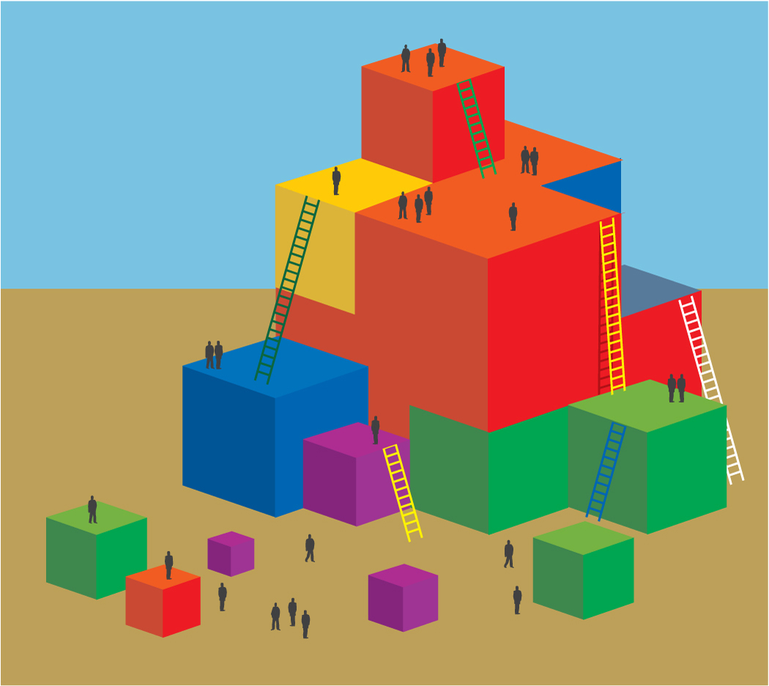
Process:

- Place the signs high on the walls around the room, with as much space as possible between each sign, so participants can have focused conversations and not be distracted by other groups.
- Ask participants to think about the health practices that they have performed in the last 24 hours. Instruct participants to quickly jot
down the first 3-5 that come to mind on a sticky note.
- When all participants are done, ask them to walk around the room until they find a sign that matches one of health practices they have written on their sticky note. If they do not have a match, ask participants to go to the “other” sign.
- Once participants are in groups next to a sign, have them answer the following questions together:
  - Washing hands is a healthy habit/nutritional/preventative measure…what other healthy habits have your participated in today?
  - How do you feel about these healthy habits?
  - Why do you choose to do them?
- Ask participants to return to their tables.
- Debrief with the next slide and have participants stand up using the following groupings:
  - Stand up if you think you stood by a health habit.
  - Stand up if you think you stood by nutrition practice.
  - Stand up if you think you stood by a safety practice.

OPTIONS:

- You can ask participants to do this activity again at the end of the session to see if their feelings have changed about health.

SUMMARY:

- Once participants begin to talk with others in the group, they will uncover similar experiences and will freely share amongst each other.
- Participants will relate their everyday experiences with the content of the module.

