Nutrition Activity: Food Plate Toss



intent:

The intent of this activity is to have participants experience an activity that can be used in the classroom for nutrition content.

OUTCOMES:

Participants will reflect on their personal knowledge of nutrition. This activity will help launch module content regarding the nutrition strand, and serve as an example activity for teachers to do with students.


Materials Required:

For Inside Play:
● Drop cloth with food plate on it, or colored masking tape
(Orange, green, red, blue, and purple)
- Objects representing foods from each food group
- Name cards for each of the five groups (grains, vegetables, fruits, milk, meat & beans)

FOR OUTSIDE PLAY:
- Sidewalk chalk
- Name cards for each of the five food groups
- Bean bags with pictures of foods on them

Time: 5 minutes

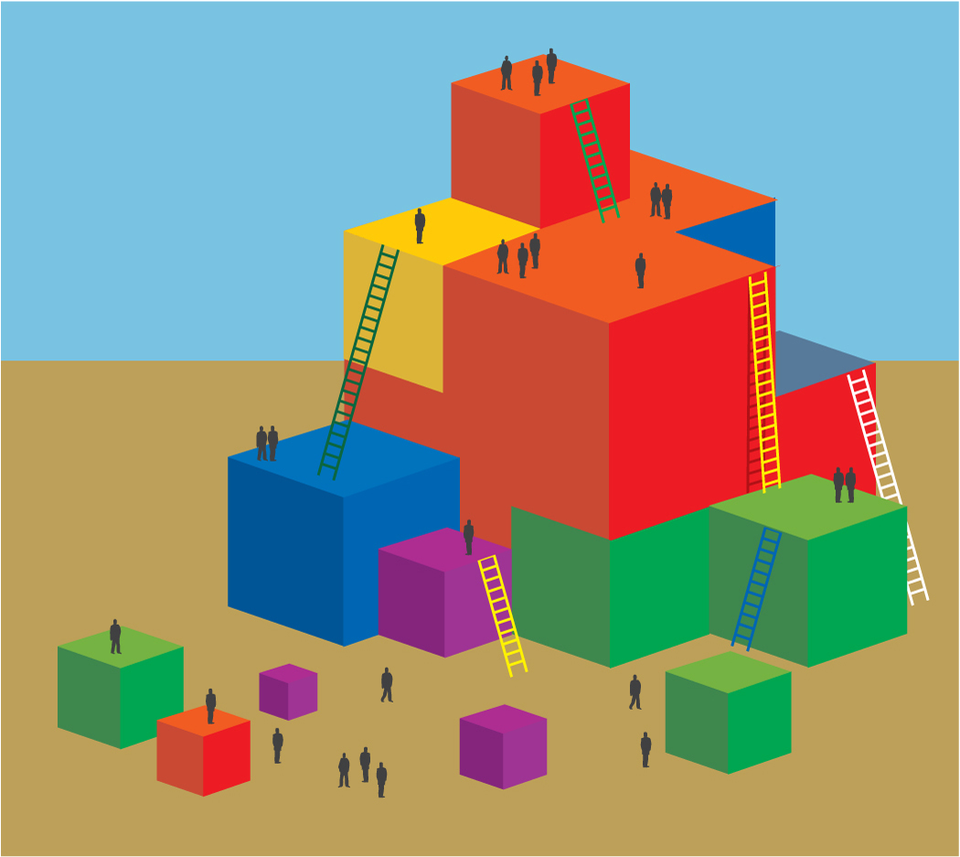
Process:

Prior to engaGing in this activity:
- One or two days prior, introduce the food plate with another activity or book such as The Beastly Feast, by Bruce Goldstone.

THE DAY OF THE ACTIVITY:

- Place drop cloth on the floor with the food labels clearly displayed.
- Review food group names and contents to remind everyone of the food plate organization.
- Have a variety of pictures, or objects, representing foods from each of the five food groups in a bag that participants will blindly reach into, pulling out a food item.
- Ask for 4-5 volunteers to join you.
- Ask the first volunteer to reach into the bag and choose a food object/picture.
- After participant pulls out an object/picture, provide support to identify the food group the object belongs to.
- Then guide the participant to stand on the food plate in the correctly corresponding place (i.e., match the food to the correct food group and stand with the object on the drop cloth).
- Repeat these steps for the remaining volunteers.
- Guide participants to discuss what ways they might front load, enhance, and expand this activity to meet the needs of all children in their program.
- Ask participants to analyze which foundations in the nutrition strand might be supported by this activity.
- Group size permitting, invite participants to share out their ideas.
- Option—Have two groups join together to share their ideas with each other.
- Have participants return to their tables.

OPTIONS:

- Model how to play the game for the participants including the adaptations/accommodations.
- After reading the book, work with the group to compile a list of 10 foods from the story. Use these to make the picture cards.
- While engaging in the activity, discuss the integrated nature of the activity (e.g., practicing vocabulary [L&L], tossing the beanbags [PD], taking turns and group participation [S/E], number of beanbags tossed [Math]).

SUMMARY:

- My Food Plate is an effective graphic organizer for children to remember what foods are important and nutritious.
- Engage in nutrition activities to serve children as they mature and develop.
- Keep the activities fun, interactive, and integrated to solidify the information.

