Self-Cultural Reflection



intent:
Participants practice using an interaction and strategy for personal reflection and intentional planning.

OUTCOMES:
Participants deepen their knowledge of the social science domain and experience one way to apply an interaction and strategy.


Materials Required:
- PPT slides
- Tablemates

Time: 15 minutes
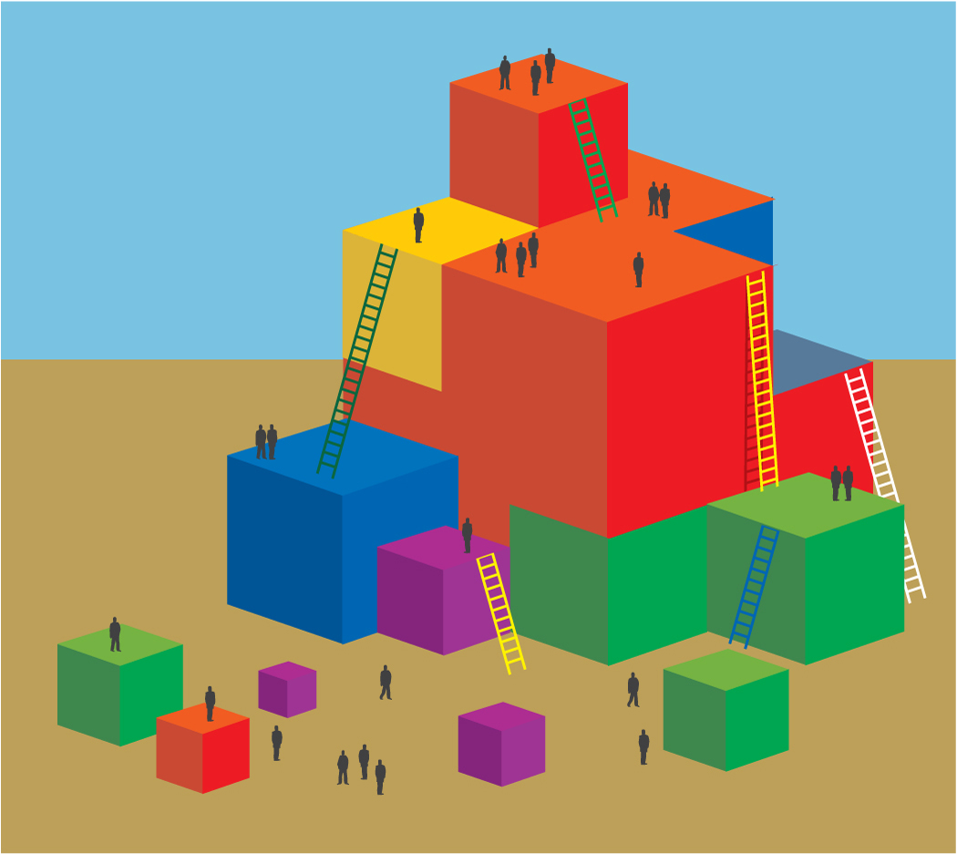
Process:
- Discuss the following interaction and strategy:
  - Practice a reflective approach to build awareness of self and others.
- Prepare participants by sharing that we will do one activity together that may help us begin to reflect and build awareness.
- Firstly, silently think of an activity that you remember doing as a child that has meaning for you. It may be baking with your grandmother, building in the yard, drawing in sand, etc.
- Secondly, think about what cultural messages you may have gained from this activity (It may necessary to model by sharing your memory and messages out loud before providing time for participants to think.).
- Thirdly, turn and share your memory and messages with your elbow partner.
- Finally, reflect with your elbow partner on the messages you may have taken from this, and other similar experiences, that you might also pass forward in your teaching.
  - Example: My memory is walking with my grandfather around a pond and collecting rocks and sticks. I did this activity every time I saw my grandfather. The cultural messages I got were that exercise and movement were good, that nature was interesting, and that spending time to explore was valuable. I especially think the cultural value of exercise is important, and spending time to explore is valuable in my teaching, friendships, and work place.
- Invite participants to share out their stories if they choose (no more than three-four).
- Now we have begun to apply an interaction and strategy. We can see how our own experiences, even as young children, can influence the experiences we create for children or adults in our care. Let’s turn to the Questions for Reflection to further out thinking.
- Invite participants to think about and discuss the Questions for Reflection with their tablemates.
  - What are some of your own biases and “blind spots” about people whose racial or cultural background are very different from yours?
  - In what ways could you partner with families in your preschool program to support attitudes of acceptance and inclusion?
- Have participants to write down any “aha” moments they may have experienced on their Rainbow of Ideas handout.
*NOTE: This subject matter is very personal and it may be threatening for some to share out loud.

