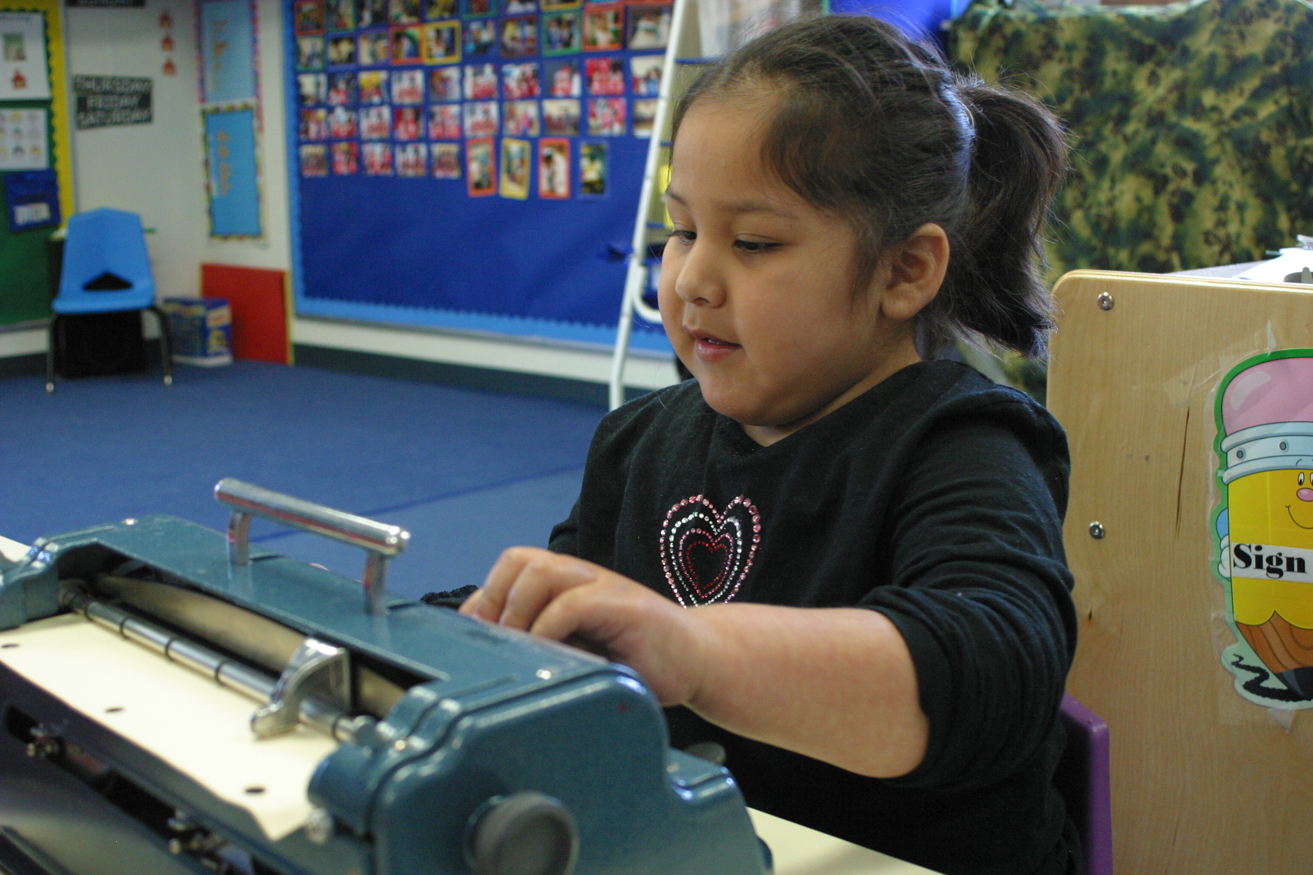
Meet Bianca
Bianca is 4 1/2 years old. She
has a visual impairment and
cognitive delays. She is
learning to use a cane and a
Braille writer.

What will you do to ensure that Bianca can participate in and access this activity?

What adaptations or accommodations will you provide?

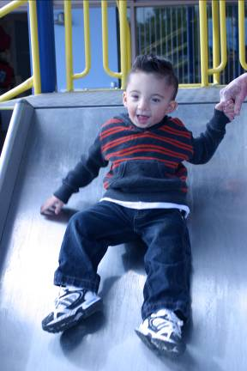
Meet Jacob
Jacob he is 3 1/2 years
old. He has a hearing
impairment.

What will you do to ensure that Jacob can participate in and access this activity?

What adaptations or accommodations will you provide?

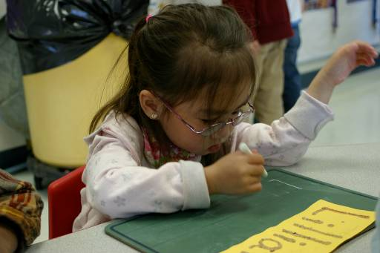
Meet Teresa
Teresa is 3 1/2 years old. She
has visual impairments.

What will you do to ensure that Teresa can participate in and access this activity?

What adaptations or accommodations will you provide?

