What do you wish for??


intent:
The intent of this activity is to have participants begin
thinking about literacy in a larger context.

OUTCOMES:
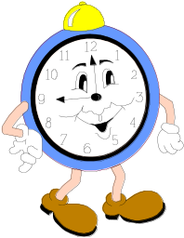
Participants will brain storm regarding the ways they hope their students develop with regard to literacy.


Materials Required:
- Sticky notes
- Table mates

Time: Part 1:10 min / Part 2:10 min

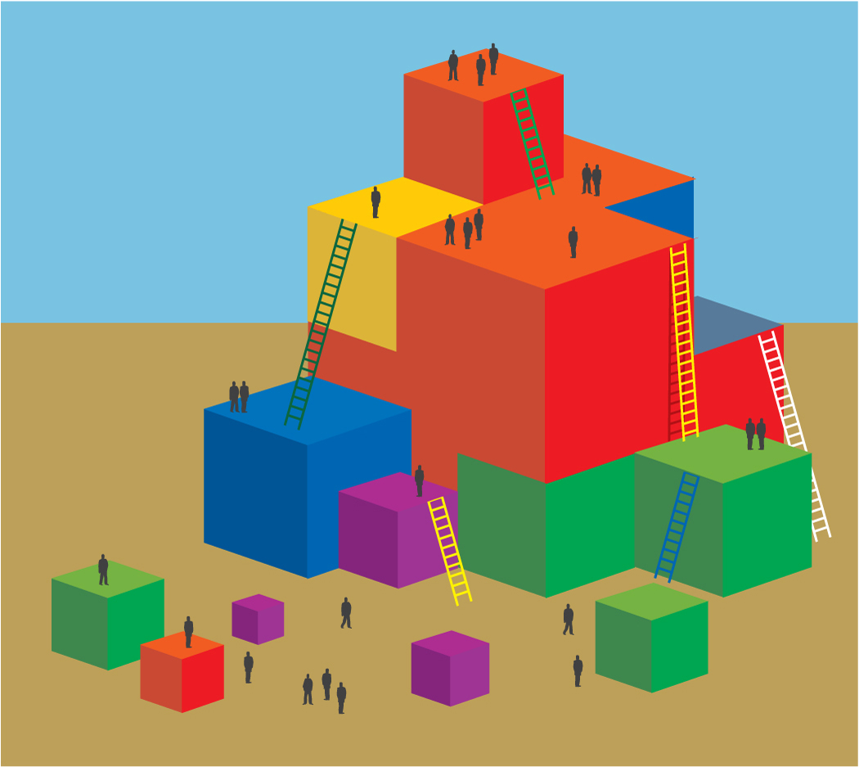
Process:
Part 1:
- Invite participants to take 2 minutes to silently write down all the experiences and abilities they hope their students develop with regard to literacy.
- NOTE: The question is broad in order to leave room for personal choice. If participants ask for examples, then provide them, but do not limit the brain storming session.
- After two minutes, invite participants to share within their table groups.
- Have each table group combine their individual lists in order to create one complete list that represents their group’s ideas. Each idea should then be written on one sticky note. Each table group will finish with a pile of sticky notes on which are written the separate ideas that represent each individual’s silent brain storm.
- Once the table groups have compiled their sticky note list, allow time for discussion.
- Regroup by asking each participant to touch the sticky note that most resonates with them.
Part 2
- Ask participants to find their Venn Diagram (on the center of the table).
- Direct groups to sort their sticky notes by what type of outcome the hope represents (individual, societal, or both).
- Allow ample time for sorting.
- Regroup by asking participants to touch:
  - The sticky note that was the hardest to categorize
  - The sticky note that most resonates with them
Reflect with participants:
- Is the sticky note that resonates most with you the same, or did it change during this activity?
- Through focusing on both the social and individual outcomes for children, can we enhance how we facilitate literacy for all in our classrooms?

