Becoming an Expert



intent:
The intent of this activity is to familiarize participants with the structure and content of the Language and Literacy (LLD) sections in the Preschool Learning Foundations (PLF) and Preschool Curriculum Framework (PCF), and to introduce them to additional strategies to support English learners.

NOTE: Information for one substrand is provided as an example, so participants will only be researching eight substrands.

OUTCOMES:
- Participants will actively engage with the PLF and the PCF.
- Participants will also become familiar with the overall structure and content of the language and literacy sections in the PLF and PCF.
- Participants will explore one substrand in-depth, sharing key information with table groups.
- Participants will use the key information throughout the module.


Materials Required:
- Index cards (9 per table)
- Becoming an Expert handout with sample on back
- LLD domain in the PLF pp. 47-101
- LLD chapter and ELD chapter in PCF
Time: 45 minutes

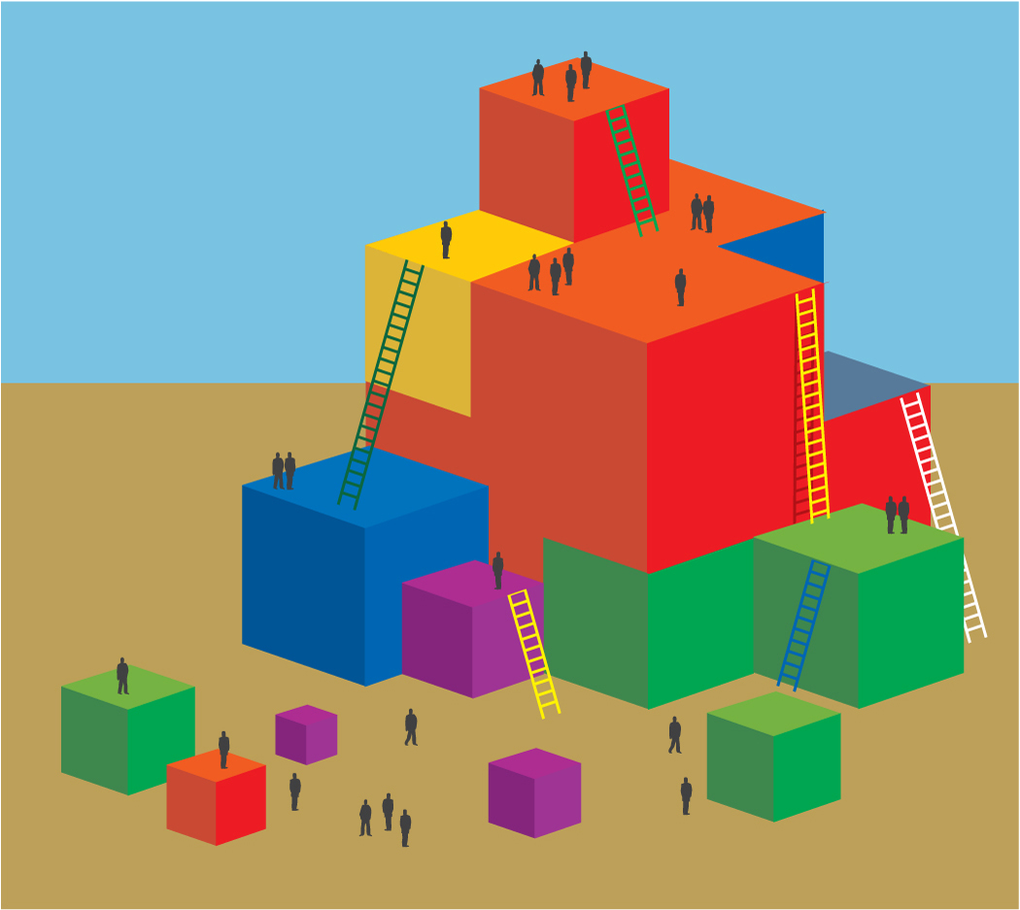
FIVE PART Process:
Part 1: Completing the substrand cards (5 minutes)
Participants will do the following:
- Use the nine blank index cards on the table.
- Review the three strands of listening and speaking, reading, and writing to identify the nine substrands.
- Print the name of one substrand on each of the nine index cards.
- Keep the cards for later use.

Part 2: Completing the matrix: “What is it?” (15 minutes)
Have participants pull out the substrand card for language use and conventions, as is demonstrated on the handout. Each participant will do the following:
- Draw one of the substrand cards from the cards created earlier.
- Read the notes and record a few key ideas about the assigned substrand.
  - NOTE: The notes are located in the introduction, beginning on page 49.
- Complete the “What is it?” section of the Becoming an Expert handout for their substrand.
- Share the highlights from their handout with their table group.

Part 3: “What might you observe children doing?”
(15 minutes – 10 minutes to write and 5 minutes to share)
Participants will do the following:
- Find and read the examples for their substrands.
- Complete the “What might you observe children doing?” column.
- Share the highlights from their handouts with their table group.

Part 4: “What can teachers do to support all learners in this substrand?”
(15 minutes – 5-8 minutes to write and 5-7 minutes to share)
Participants will do the following:
- Using the PCF, write ONLY three strategies for their strand from the interactions and strategies section.
- Share the highlights from their handout with their table group.

Part 5: (10 minutes – 5 minutes to write and 5 minutes to share)
Participants will do the following:
- Ask participants to consider the last video clip, Three Billy Goats Gruff, or show the clip again.
- Use the ELD chapter of the PCF and write two strategies for Francisco.
- Share the highlights from their handout with the table group.

OPTIONS:
- If a table group has fewer than eight people, consider combining the writing substrand with the concepts of print substrand, or another substrand that doesn’t have as much content.
- Preprint the substrand cards if short on time.
- Assign one substrand to each table group, ensuring that each table explores a different substrand. NOTE: In this case, it is recommended that time is allowed to debrief, and participants use chart paper to record key points. Debriefing options include, but are not limited to, table groups share-out, wall walk, or carousel.

