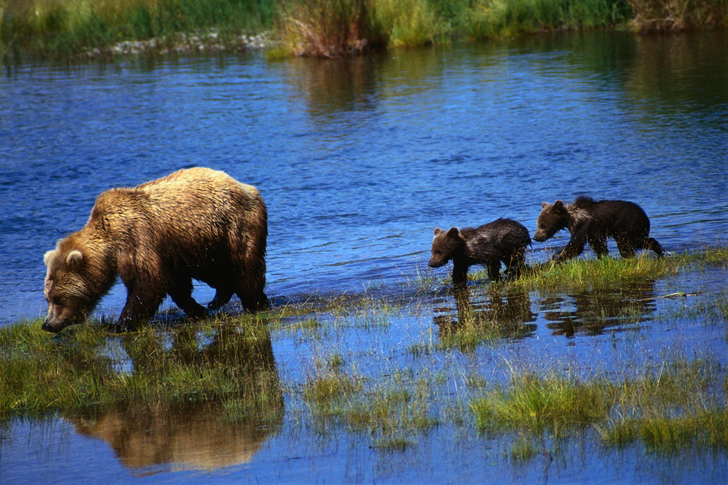
Bears in a Cave!

Materials:
- One “cave” made from an overturned paper bowl. Cut a small curved opening for the entrance to the cave.
- 5 small plastic bears (or any number appropriate)
- Number line up to 5 (for support)

Activity:

Model and play with one child first. “5 bears are on a picnic and they decided to play a game of hide and seek. Some of them hide in a cave. Close your eyes while I hide them.”

Leave the remaining bears in plain site. The child opens her eyes and tries to guess how many bears are hiding in the cave. Refer to the number line if necessary.

Now let the child be the narrator and hide the bears from you. Then have children play the game with each other. Use other small animals.

Adaptations:

- Start with a smaller number of bears and progressively add more as the child becomes adept at larger quantities. Have number lines that reflect that amount (to avoid confusion).

