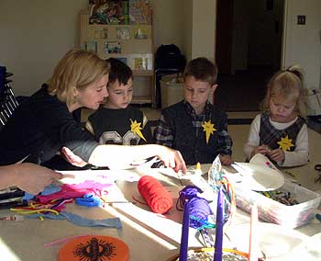Number Sculptures

Goal: To connect number words and numerals to the quantities they represent.
Materials: A piece of styrofoam (about 2-3 inches long) for each child. A variety of scrap materials, such as straws, feathers, popsicle sticks, ribbon, yarn, golf tees, stickers, foam pieces, foil, pipe cleaners and glue. You could also use poster board or clay for the base of the sculpture.
Description:
- Explain the activity by modeling a sculpture. First role the die. Make a “sculpture” using the same number of items as the number rolled. For example, if a number 3 is rolled, make a sculpture using 3 straws, 3 red ribbons, 3 yellow plastic flowers and 3 blue triangles.
- Have the children role the die and make similar sculptures themselves. Writing the number down on a piece of paper next to the child with small dots to represent the number can be a helpful reminder.
- Have other children try to guess what number was rolled on the die to make the sculpture. Another fun activity is to suggest that children describe their sculpture using position or descriptive words, and have their peers try to identify the sculptures being described.
Expectations:
- Children enjoy making sculptures and may forget the number of items they are supposed to be using. They may simply add lots of objects because they are pretty and easy to place.
- Children may not use numerals or descriptive words when they describe their sculptures. You may need to ask additional questions to help them make their descriptions more explicit.
- Some children will create symmetrical sculptures whereas the work of others will be random. Observe children who are able to keep track of how many items they have counted for their sculptures and their specific procedures for doing so.
Suggestions for Supporting Learners:
- For children that are having trouble selecting the right amount of items, ask them to select their items before they put them on their sculptures.
- For children who are having difficulty describing their sculptures, ask them questions using position, color, and number words for example, “How many straws are on top of your sculpture? How many are under the foam piece? How many ribbons are blue? How many are curly?” You might also partially describe the sculpture and ask the child to finish the description.
- For children who are having difficulty identifying the number represented by a particular sculpture, ask them to eliminate specific values represented on the die. Ask, “Could it be ‘1’? Why not? What about 6? How did you know the number wasn’t 6 without even counting?”
- For children with visual impairments, make your own large die with numbers that stand out by gluing on objects that are flat on one side and rounded on the other, such as googly eyes, to represent the numbers.

Source: Copley, Juanita. Showcasing Mathematics for Young Children. NAEYC, 2004.

