THE PEACE GAME
(FORMERLY “WAR”)

Goal: to practice counting, one to one correspondence, subitizing (instantly recognizing the amount), and turn taking

Materials needed: 10 index cards; many sticky dots.
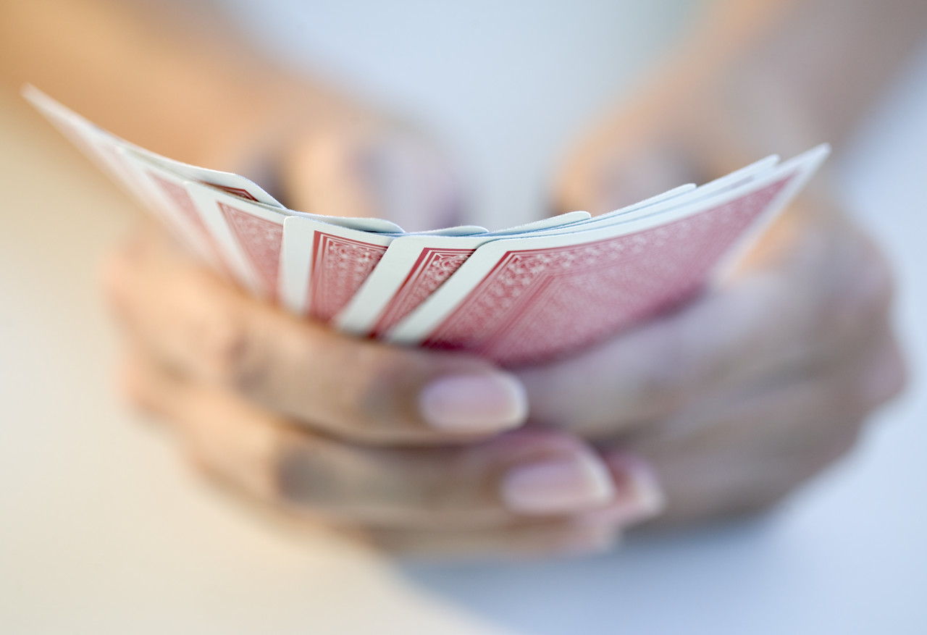
Card 1 – put on 1 sticky dot (use only one color for this set of 5 cards)
Card 2 – put on 2 sticky dots
Card 3 – put on 3 sticky dots (in a row)
Card 4 – put on 4 sticky dots (in a row)
Card 5 - put on 5 sticky dots (in a row)

Then make one more set of cards in the same manner but using dots of a different color.

How to Play:

Each player gets one set of 5 cards (same color dots). Player mixes up the cards and puts them face down in front of him. Then, at the same time, each player turns over the card on top. The player with the highest card gets to take both cards. Keep going until one player has all the cards.

What if the same card comes up? You could ask the children what they think should happen. (When I played this as a child, we just kept going, which meant the pile of cards got a little bigger.)

Variation:

- First player turns over his card and tells opponent how many dots. Second player turns over his card and does the same. Player with the higher hand keeps both cards.
- Make a set of cards with the dots in different patterns (like on dominoes).
- Make a set of cards using more dots.
- Add numerals to the dots.
- Use real playing cards.

