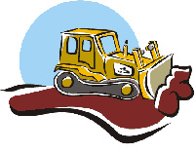
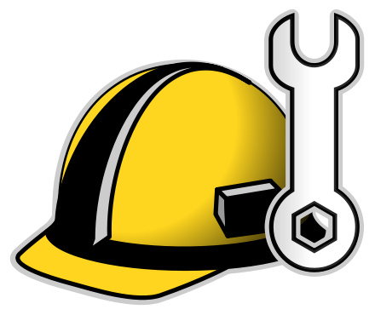
Bulldozers and Construction Workers

Background:
Children pretend to be bulldozers and construction workers. Children either build (standing cones up) or bulldoze (knocking cones down).

Get Ready:
- Space: Indoors or outdoors (large enough space to allow for movement to increase heart rate)
- Materials:
- About one cone per child playing (If you do not have cones, use liter bottle with a bit of sand so they stand up better.)
- Large group or small group depending on the space and familiarity with the game.

Get Set:
- Adults help children decide if they are a construction worker or a bulldozer. Game works best if there are an equal numbers of both.
- Adults place the cones around the area with enough space that children can move around the cones.

Go:
- Tell the story: These buildings need to be built and bulldozed. Each of you has a job. Once the bulldozer knocks the building over, the builder must come rebuild it. Then it will happen all over again.
- To begin the game, ask, “Bulldozers are you ready? Construction workers are you ready? Go!”
- All children begin moving around the cones completing their assigned job.
- After about one minute, adult can regroup children.
- Children switch jobs and then repeat the process.
- After a few turns, begin to ask children to use different locomotor movements. The crab walk is especially challenging, but fun.
Tip:
Spread the cones out for children who are using assistive moving devices. It can be frustrating to knock cones over as you are moving.

