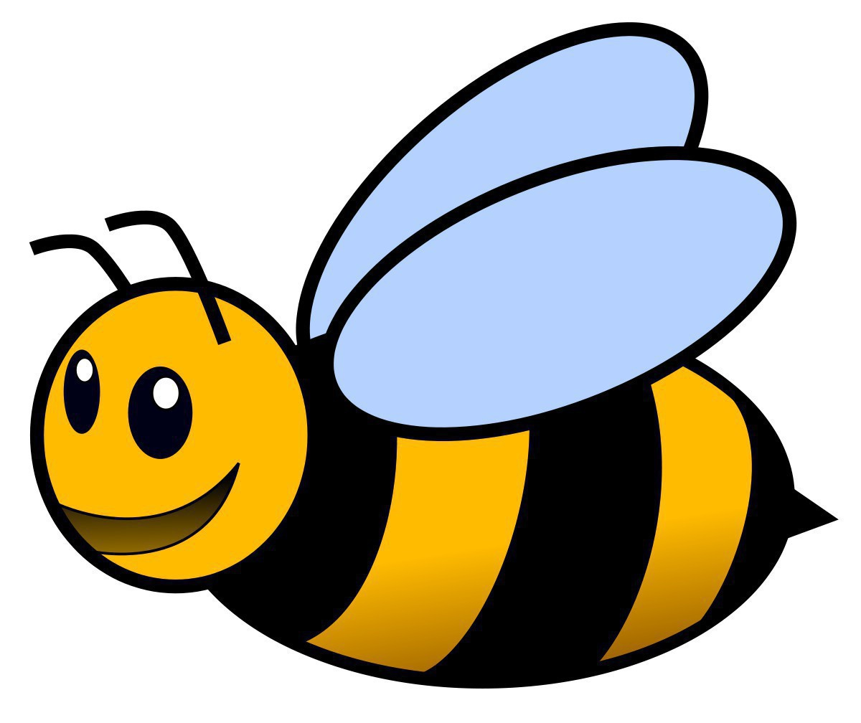
Bumble Bee Bop

Get Ready:
- Space: Indoors or outdoors
- Materials:
- 10 – 12 plates with flowers drawn on them placed around the area (Place them high and low.)
- Music playing or sound effects of bees buzzing

Get Set:
- Children will move from flower to flower making buzzing sounds and flapping wings gathering pollen and return to the queen bee.
- Adult is a queen bee or another child.

Go:
Bees are directed by queen been to move in different ways, or children can make suggestions in response to queen bee, asking, “Now how shall we move?”

- Skipping
- Running
- Hopping
- Jumping
- Sliding
- Marching
- Crawling
- Crab Walking
- Galloping

Tip:
Although the game can be played inside, it is best to play in a large area when possible so children can move freely and quickly to increase their heart rate.

