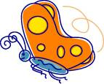
Movement and Imagination

Get Ready:
- Space: Indoors or outdoors
- Materials:
- None
- Time: As long as children are interested

Get Set:
- Adult calls out a challenge and children move about the space in response to the challenge.

Go:
Can you…
- Soar like a plane?
- Bounce like a ball?
- Spin like a blender?
- Fly like a kite?
- Walk like a robot?
- Slither like a snake?
- Pounce like a lion?
- Move like a dump truck?
- Walk like a crab?
- Roll like a log?
- Move like a butterfly?

Tip:
- Create additional ideas before you begin the activity so you have lots of ideas at hand.
- Ask children to come up with ideas.

