Putting it All Together

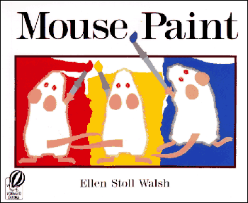
Visual Art
Mathematics
Number sense, Algebra, Measurement, Geometry, Mathematical Reasoning

