Strength Surfing



intent:
Engage participants in thinking with a science lens; acknowledge prior knowledge of science.

OUTCOMES:
Build community, become aware of different strengths in the room, and connect existing teaching qualities to science development.


Materials Required:
- PPT slide
- Trainer notes
- Surf board cut-outs
- Crayons
- Pencils
- Markers
- Table mates

Time: 10 minutes
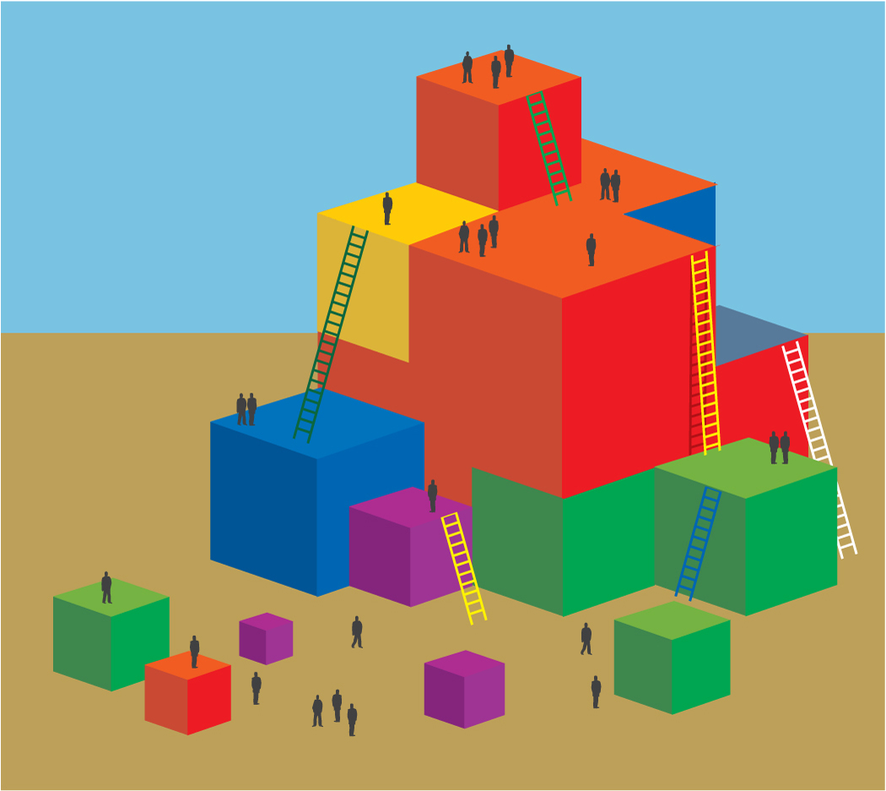
Process:
Preface: We are going to explore the teacher component of interactions and environment; refer to slide six in the PPT.
- Each table group to finds and begins to decorate their individual surf boards; explain that the surf boards will be used for activities throughout the day.
- Remind participants that we have talked about using the tools we already have to create a culture of scientific inquiry. Just as science for preschoolers is about tapping into interests, teachers too can utilize their strengths and build upon them.
  - For example, although the skills used in developing language, supporting an outdoor environment, and engaging children’s creative skills are all incredibly integral to science, we don’t always think of them as being as “science” related. These are strengths that can be built upon.
- Participants write down their strength on the top of the board.
- Participants flip their surf boards over to the back side and write what they perceive their weakness to be.
  - Focusing on this “weakness” could capsize the board so turn it back over.
- Participants stand and pair up with someone who has a similar strength.
- Partners discuss their mutual strength and how it could be used to promote science in the classroom.
- Partners find another a pair with a different strength and create a group; groups compare and contrast strengths.
  - If you were partners in a classroom how would you build on each other?
- Still in groups, participants flip surf boards over and compare and contrast weaknesses.
  - If you were partners in a classroom what would you need to consider in creating the culture of scientific Inquiry in your classroom?
- Invite participants to display their surf board and share their strengths. Ideas for display:
  - Display on table group tables
  - Display at front of room
  - Display on wave at front of room

Debrief:
- What was interesting to you about the conversations you had?
- Was something you found surprising?
- How might you use what you felt in this activity in the classroom?
- What is one new idea regarding science that you can add to your classroom that utilizes your strengths as a teacher?

