Surf’s Up Inquiry



intent:
Engage participants in the process of scientific inquiry (engage, explore, and reflect) and experience observation, investigation, documentation, and communication.

OUTCOMES:
Participants build community with each other, experience observation and documentation, and reflect on other domains addressed (STEAM).


Materials Required:
- PPT slide
- Open-Ended Questions handout
- Trainer notes
- Container with different ocean objects for each table (seashells, driftwood, glass beads, sand, rocks, etc.)
- 5 x 7 cards
- Colored pencils, markers, crayons
- Participant phones and/or tablets
- Chart paper for each table group
- Scratch paper
- Magnifying glass
- Different color cellophane goggles
- Popsicle sticks (potentially used for measuring)

Time: 20 minutes
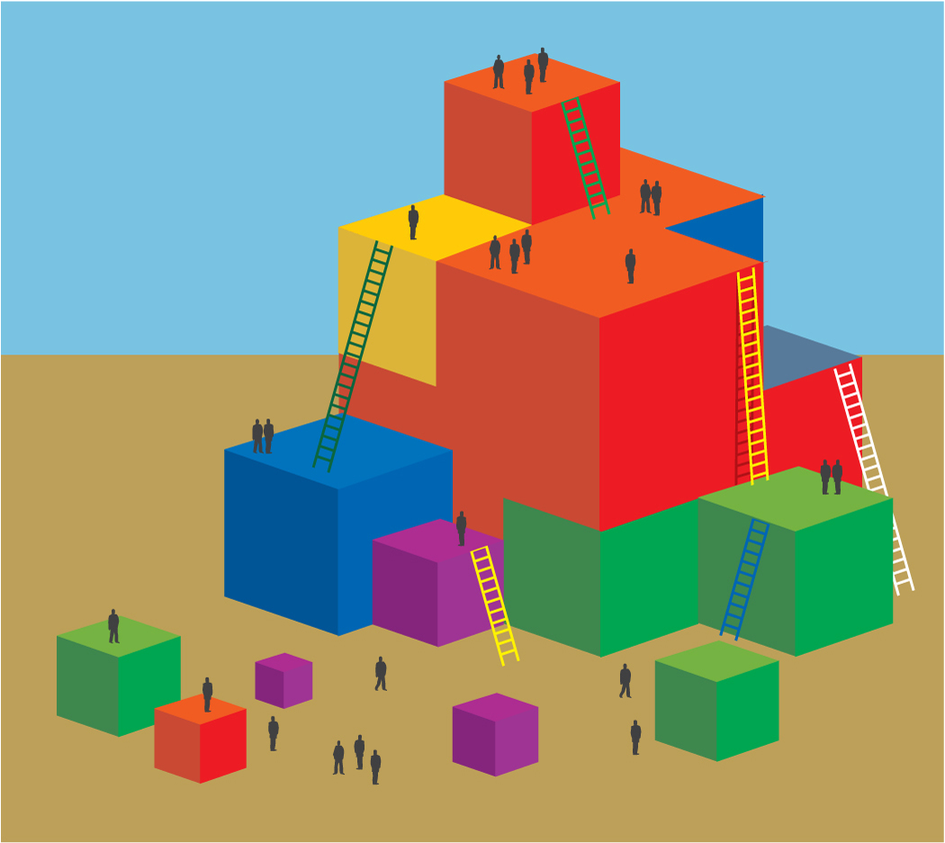
Process:
- Each table group finds their “Surf’s Up” objects.
- Invite one person from each table group to come to the front to get their bag.
- Advise table groups that the tools in their bag will be used for the process of scientific inquiry (engage, explore, and reflect). This
process will include observing, investigating, and documenting.
- Trainer front loads the activity by stating:
  - Remember that inquiry is meaningful when it builds on children’s prior experiences. Today we are building on our “surfing” context. These materials will also likely be familiar to many of your students.
  - As a group, you are going to walk through the process of inquiry (engage, explore, and reflect). Within this process you will practice the basic skills of scientific inquiry as they are outlined in the PCF. Take a moment now to find Handout 5: Surf’s Up Scientific Inquiry. This handout will be useful as you go through this process. Take notes to help you identify the different inquiry skills you are practicing:
    - Make sure to observe differences in height, weight, size, shape.
    - Compare and contrast a variety of objects.
- After you have done significant observation and investigation, you may begin documenting your discussing and findings. You may do this using any materials you have in your bag and any other materials you may have with you today that you would like to use. For example, it is acceptable to use your phone or tablet to document if you choose.
- After you are satisfied with your documentation, you will use your chart paper to graph your findings. Groups will decide the best way to do this; there is not a right answer for the graph.
- Once participants all have their documentation materials and understand the directions trainer says, “Ok you may now begin investigating and observing your Surf’s Up materials.”

TRAINER NOTES:
- Allow ample time for this investigation (8 minutes).
- While participants are investigating, wander around the room and provide question prompts.
- After participants are done observing, request that they begin documenting what they have observed. Participants may have begun this process already, but encourage participants to use materials such as markers and crayons for documentation in order to get a larger variety of documentation.
- Once participants have a significant number of observations documented, direct them to their individual group chart paper and suggest they use their chart paper to graph their findings.
  - Graphing the findings should produce a variety of charts and graphs, and demonstrate the different types of documentation.
  - Groups may also want to record the different types of open ended questions and scientific language they use.
(Refer to Open Ended Questions and Science Glossary HO as needed).
- Once the charts are complete share out by:
  - Inviting a few groups to share their work
  - Providing a summary of the variety of graphs you found
  - Snapping photos of the graphs and creating a slide show at the front
  - Inviting participants to do a gallery walk to look at all the charts
- While the share-out occurs, lead a discussion following the points that should be addressed:
  - The substrands of scientific inquiry include observation and investigation, and documentation and communication. With this activity we addressed three of these areas. We did not investigate thoroughly. A true investigation happens over time. In other activities today we will simulate more investigative processes.
  - We all came here today with a multitude of experiences with science and different strengths, but because we are all using the same real materials in front of us we had a starting point for our conversation. These materials provided context and are an especially helpful aspect of science for children learning English as a second language.
  - We used and practiced knowledge from other domains in the activity. For example, graphing was math, and some of the documenting was art and/or literacy.
  - STEAM is a prevalent concept in the education world; it stands for science, technology, engineering, art, and math. Which of the STEAM items did we hit upon?
      - Science
      - Technology (the different tools we used, and perhaps even the tablet for documenting)
      - Engineering (possibly, if participants built something)
      - Art (possibly, depending on how the charts were created and how the documentation was done)
      - Math (comparing, contrasting, and graphing; potentially measuring)

