Balance Exploration



intent:
Provide a culminating experience utilizing all the skills practiced within the Scientific Inquiry strand.

OUTCOMES:
Participants experience balance activities and practice scientific inquiry.


Materials Required:
- PPT slide
- Jump ropes
- Balance games (spill the beans, hanging monkeys, wobble board, crepe paper, twister, jenga, etc.)
- Magnifying glass
- Flash light
- 3 x 5 cards
- Chart paper
- Markers
- Handout 7: Observations and Documentation
Time: 20 minutes
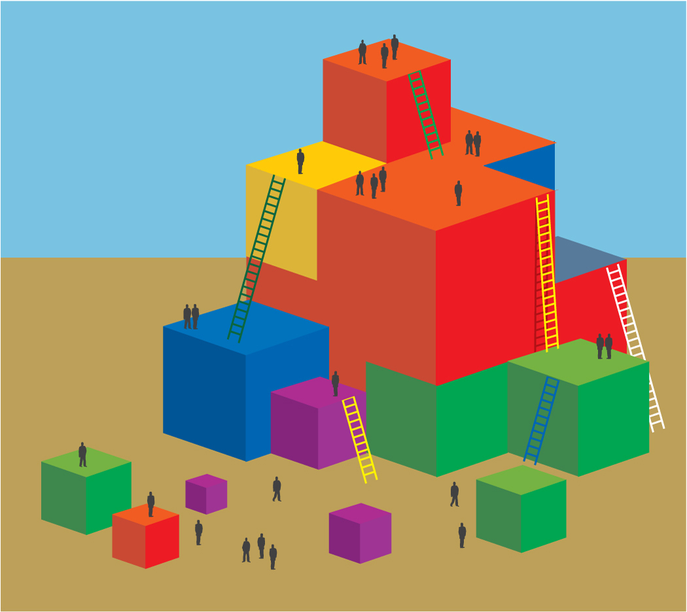
ENGAGE:
- How do we engage children? For example, after observing the children, a teacher realizes that they are curious about balance. In order to engage the children, the teacher needs to provoke more curiosity; the teacher might choose to read a book or provide an experience to incite further curiosity and engagement.
- In preparation for deeper exploration, we as teachers often need to conduct our own exploration experience before providing one for the children. We will do that now:
  - Invite volunteers to walk the tight rope. Allow the volunteers to walk any way they want. Invite the audience to observe the volunteers and to document their observations.
  - Then say, “I am going to ask you to do some specific things across the tight rope with your arms while you walk. Do you predict that this will make it easier or harder to balance? Why?”
  - Now give directions to the volunteers (arms over head, arms behind back, one arm on head one arm on tummy, etc.).
  - Check the prediction. Ask the participants, “Which felt easier?” Ask the audience, “Which appeared to be easier?”
  - Ask the group for possible explanations.
  - One trainer should chart the list of potential explanations. This will serve as a starting point for further exploration of balance.
  - Trainer says, “Now, as a group we are going to explore balance. You have several materials and there are some activities at the front that we would like everyone to rotate through and try.”
- Direct participants to utilize Handout 7: Observations and Documentation as they think of other “engage” ideas that they might use. Use the PCF for interaction and strategy ideas.

EXPLORE:
- Let’s think about exploring. What basic inquiry skills do we want to activate? As teachers, how might we facilitate this?
- Each table group focuses on two areas/times of the day to provide exploration experiences and brainstorms for ideas.
- You may use chart paper, scratch paper, or Handout 7 to guide the brainstorming session.
- Use your open-ended handout questions and write down at least three ideas for open-ended questions.
- Consider dual language children in your program. Is there another strategy you might add to these questions to increase accessibility for them?
- Think about one experience you discussed and three different ways to document this experience.

REFLECT:
- Consider how you will reflect on this experience with children. Choose two ideas regarding how to reflect in the classroom and one idea for extending that reflection into the family.
- Take a moment now to look at your brainstorming notes. Do those ideas support children in your program who may communicate with an alternative mode of communication and/or express their ideas without words? Intentionally think about how to fully engage these children in your program.

