Reflection


intent:
Think about literacy in a larger context.

OUTCOMES:
Participants brainstorm the Literacy Bill of Rights and their views on literacy for all.


Materials Required:
- Literacy Bill of Rights handout
- Chat box
      - Breakout rooms

Time: 15 minutes

Process:
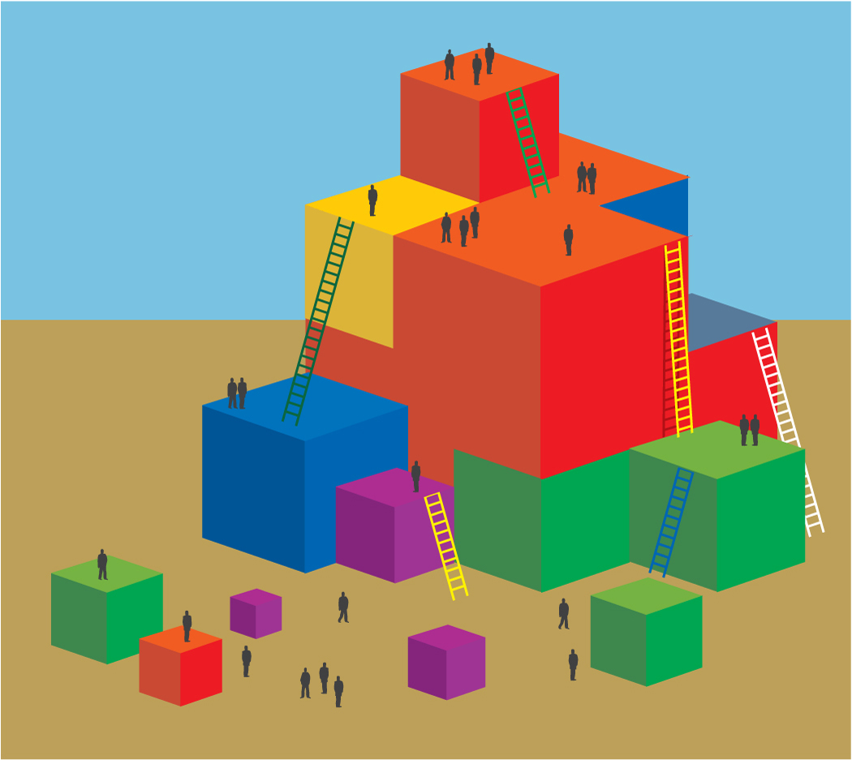
Activity:
- First, invite participants to share in the chat box what the words “literacy for all” means to them.
- Guide participants to find the literacy bill of rights handout.
- Provide participants two minutes to review the literacy bill of rights handout.
- Invite participants. In pairs, to breakout rooms and talk with their dyads about how the document may influence or change their ideas of what literacy for all means.
- Ask participants, as they come back to the larger group, invite them to share in the chat box highlights of their discussion.

Reflect with participants:
Through focusing on both the social and individual outcomes for children, can we enhance how we facilitate literacy for all in our classrooms?

